# Computing Coursework

Contents

Computing Coursework 1

Project definition 3

Analysis 4

Project Description 4

The problem 4

How this product will solve the problem 4

How this product is amenable to a computational approach 5

Stakeholders 6

Who it is for 6

How the product will help them 6

Stakeholder interviews and form 6

Interview 6

Analysis of stakeholder interview 7

Stakeholders feedback 9

Analysing Feedback of Form 11

Research 12

Existing products 12

Pawshake.com 12

Trusted housesitters.com 14

HouseSittersUK.com 18

Essential features 21

Limitations 21

Specification 22

Success criteria for the project 22

Design 23

Tables In Database 23

Usertable 23

Cat Sitter Table 23

booking 24

Webpage design 25

Top Down Design 25

Front Page 26

Login Page 27

Sign Up page 27

View Bookings 29

Create Booking 30

Pet sitter View Bookings 31

## Project definition

The problem that I want to solve is that it is hard to find cat sitters. This can be a problem because when you go on holiday you have no way to feed or make sure that your cats are ok. Making a website where cat sitters can be found will make the process of searching for a cat sitter a lot easier because you will know where to look. This would make booking holidays a lot easier because users wouldn’t have to worry about how they will make sure their cats are looked after when they aren’t there. This product will also make it a lot easier for cat sitters to find clients, because most people wont need a cat sitter all year round. It will also only be in Hertfordshire, which ensures that the clients are always living near to their clients. It will also allow the clients to put in the dates that they want a cat sitter on. It will also need a rating system.

# Analysis

## Project Description

### The problem

The problem that this product wants to solve is that when you go on holiday your cats are left at home alone. This means that there is no-one there to feed them, or to make sure that they are ok. This is a problem because if you are on holiday for multiple days there would be no-one at home to feed your cats, or check that they are ok. This could lead to your gets getting hungry or getting hurt. Although you can go around asking random people if they can look after your cats it will take a long time to find a person who is willing to look after your cats. This is a very inefficient way to search for a cat sitter, and if you are pressed for time, because you forgot that your cats existed, it would be very stressful to do.

Another problem is that it is hard for cat sitters to find clients that live near to where they live. This is a problem because if their client lives far away from where they live it will take a long time for them to get to their clients house, and if there is traffic the cat could be left alone for a long period of time. Living far away from their clients house also means that if they use their car the amount of petrol that they need to use to get there could be very expensive. Another problem that can happen when the cat sitter has to travel a long distance to their clients house is that their car will experience wear and tear. This is a problem because over time their car will start to break and the repairs to their car could cost a lot of money. These problems can make it harder for a person looking for a cat sitter to get a cat sitter because the cat sitters might not be willing to travel a long distance to get to their clients house.

Another problem that cat sitters face when looking for clients is that it can be hard to find clients that want their cats to be taken care of on days that the cat sitter is available to take care of cats. This can be a problem because the cat sitters might have another job, or might have other commitments, which could make it hard for them to find a client that they are able to work with.

### How this product will solve the problem

This product will have a way for cat sitters to register onto the website. This means that there would be lots of cat sitter in one place, so it will be very easy to find a cat sitter. This will speed up the process of finding someone to look after your cats a lot because you know where to look. It will also give you the assurance that the person that you are hiring to look after your cats knows what they are doing.

Another way that this project will solve the problem is because it will mean that cat sitters can search for clients in their area. This makes it a lot easier for the cat sitter to find a client that they are able to work with because otherwise they will have to search through all the possible clients to see if they can find a client that lives in their area, and want to have their cat taken care of on days that the cat sitter is able to take care of their cats.

Another way that this project will solve the problem is because it will have a way for the people that want their cats to be taken care of to put in the dates that they want their cat’s to be taken care of, and the cat sitters will be able to see this and it will make looking for a suitable client a lot easier than if they were going around asking random people what days that they want their cats to be taken care of.

### How this product is amenable to a computational approach

This product is amenable to a computational approach because I will create a website, which will allow the user to browse through cat sitters until they find a cat sitter that they think will do a good job. This method will solve the problem of cat owners not being able to find cat sitters because it will have cat sitters listed on the website, so it would be very easy to find a good cat sitter. It will also mean that pet owners can look for pet sitters, while staying at home and having the product on a website also allows multiple people to access it at once.

Making a website to find a cat sitter will make it a lot easier and faster to find a cat sitter than if the clients used traditional methods, like looking for adverts in the news paper or asking people. It will be easier because all of the cat sitters will be listed in one place and their contact information will also be listed, so a client could easily find and contact a cat sitter.

Another problem with finding a cat sitter is giving all the contact details that a cat sitter would need if something would go wrong. A way to solve this problem is to have all of the contact details that the pet sitter might need stored in a database. This would solve this problem because the website could access this database and display it in the users data, so it would be quick and easy to get a clients data.

## Stakeholders

For this project my Mother will be my stake holder. I chose my mother because she normally takes care of my family’s cats. When my family and I go on holiday my mother has to usually look for a cat sitter. I think that my Mother will be a good stake holder because she will know what would help the user find a cat sitter because she has had lots of experience finding a cat sitter to take care of our cats when we are going to go on holiday.

Another stakeholder in this project is my brother. I think that my brother would be a good stake holder in this project because he sometimes does cat sitting for people that live in in my town. This makes him a good stakeholder because he will know what features would make this project easy to use for cat sitters.

Another way that I will get data from people is by making a form, which will be sent out to lots of people. This will be useful because the responses from the form will make it very easy to see what the key points that should be added into the project are.

### Who it is for

This product is designed to make it a lot easier for cat sitters to find clients, and for people who want their cats to be taken care of. This project will help them find a cat sitter because it will be a place where cat sitters will be and they will be able to check the availability of the cat sitters. This means that it will be a lot easier to find a cat sitter if you are in a hurry, or if you have to leave unexpectedly.

### How the product will help them

This product will help the user because it will provide a easy and quick way to find a cat sitter to take care of their cats. It will do this by allowing users to input the days that they want a cat sitter to take care of their cats and their address, and after the cat sitter has finished their services they can rate them

### Stakeholder interviews and form

For this interview I interviewed my Mother. This is because she is the stakeholder for my project.

### Interview

Me: what are the problems with finding a cat sitter

Stakeholder: you need to make sure that they are trustworthy. A problem with using an online cat sitting website is that you don’t know if the reviews are true of fake. You have no way of having a criminal record check, and you don’t know if they will do what they say that they will do.

Me: do you find it hard finding cat sitters

Stakeholder: Because I have had cats for many years we know people that want to cat sit, but if I had to find a cat sitter it might be problematic.

Me: why is it hard to find a cat sitter

Stakeholder: because you don’t know who to trust

Me: how would you fix the problems with the online cat sitting websites

Stakeholder: There should be a database of good cat sitters, so there would be accredited cat sitters, so users know that they could trust the cat sitters. To make sure that the cat sitters are doing what they say they are doing, they should sent their client a video of them doing things, like feeding the cats, on platforms such as WhatsApp

Me: Are cat sitters useful

Stakeholder: yes because if you have a cat sitter you won’t have to put your cat in a cattery, which would make them uncomfortable because you would be taking them out of their environment.

Me: What are your thoughts on the alternate methods of taking care of you cats when you are on holiday

Stakeholder: they are fine if they are healthy, but they would be unhappy because they would be stuck in a cage, and out of their environment.

Me: would the cat sitter having your emergency contact details when they are taking care of your cat

Stakeholder: yes because it will allow them to easily contact me if something happens to my cat. The cat sitter should also have details for the cats vet, so they can take the cat to the vet if something happens to it.

Me: would the rating system for the cat sitter be useful

Stakeholder: yes it would be because it would allow me to trust the cat sitter more because it would show that they have experience, and are good at cat sitting.

### Analysis of stakeholder interview

In this interview my stake holder brought up problems with using online pet sitting websites. The problems that they said online pet sitting websites had was that there was no way to see if the pet sitter you hired was doing what you are paying them to do, there is no way to see if you can trust the pet sitter, and there is no way for the pet sitter to contact you or your pet’s vet if they get sick and the pet owner is in another country and cant come and take care of their pets.

My stakeholder also outlined possible ways to fix the problems that were brought up in the interview. For example a way to fix the problem that if the cat gets sick and there is no way to contact the pet owner you could have the pets vet details listed on the website, so they know where to bring the pet if the owner can’t come to take care of it.

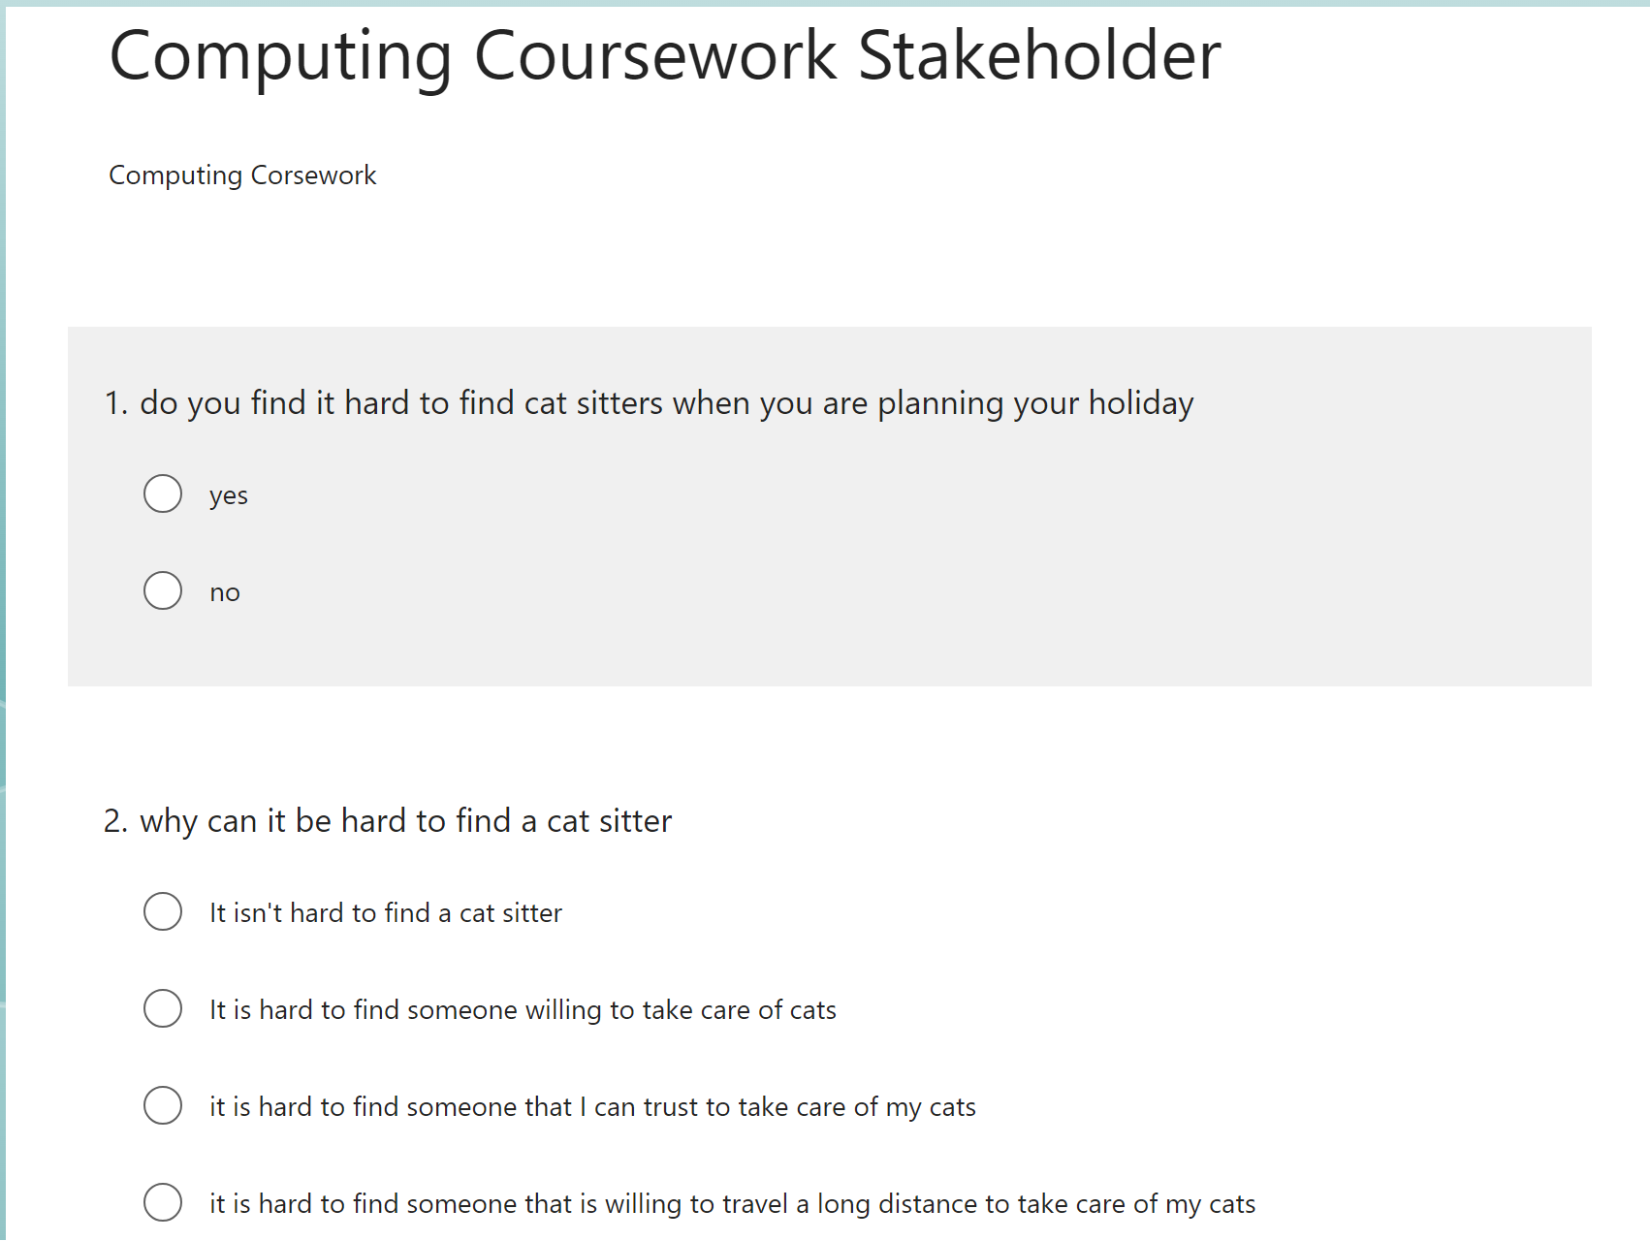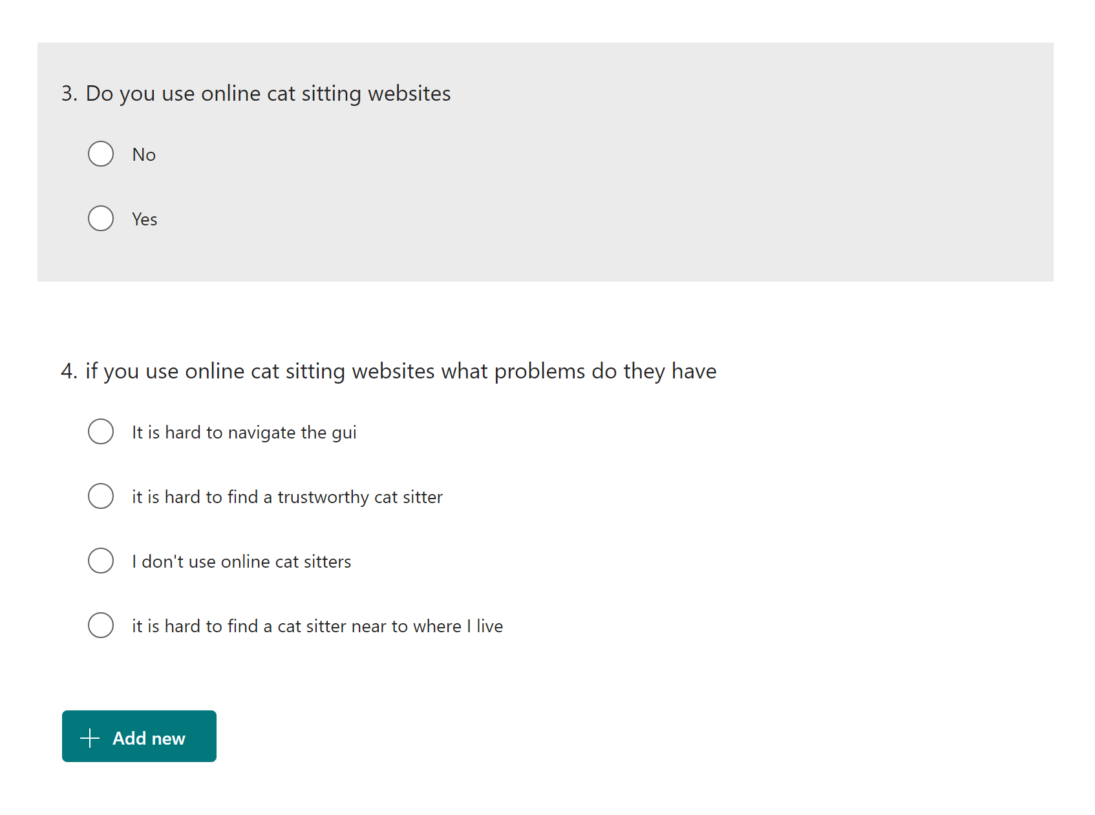

### Stakeholders feedback

Feeback from the form

### Analysing Feedback of Form

This form shows that a large proportion of people find it difficult to find a cat sitter. This data also shows that not being able to find a cat sitter that lives close to where the pet owners live. Adding a feature that only shows the users the cat sitters that are willing to travel to their area to take care of their cats. This will solve this problem because the users won’t see the cat sitters that won’t travel to their homes.

This form also shows that some pet owners don’t trust cat sitting websites. This could be because of a variety of reasons, such as they have no way of knowing if the pet sitter that they are hiring is trustworthy. Adding a rating system to the pet sitters will solve this problem because it would show that the cat sitters are trustworthy.

## Research

### Existing products

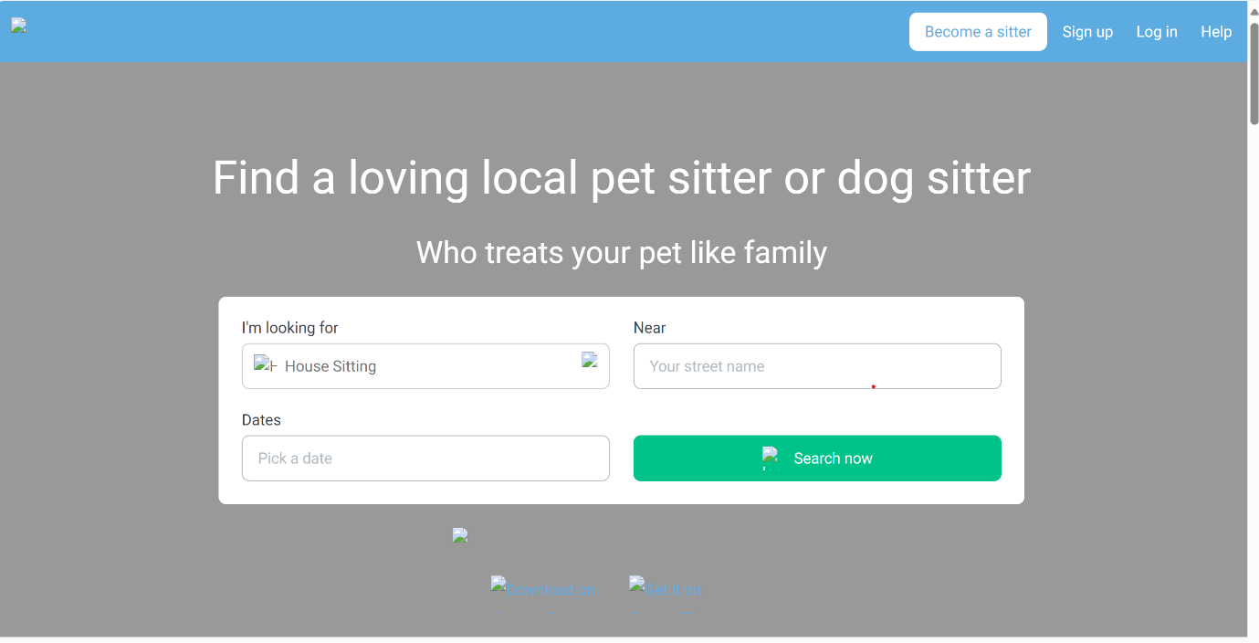Pawshake.com:

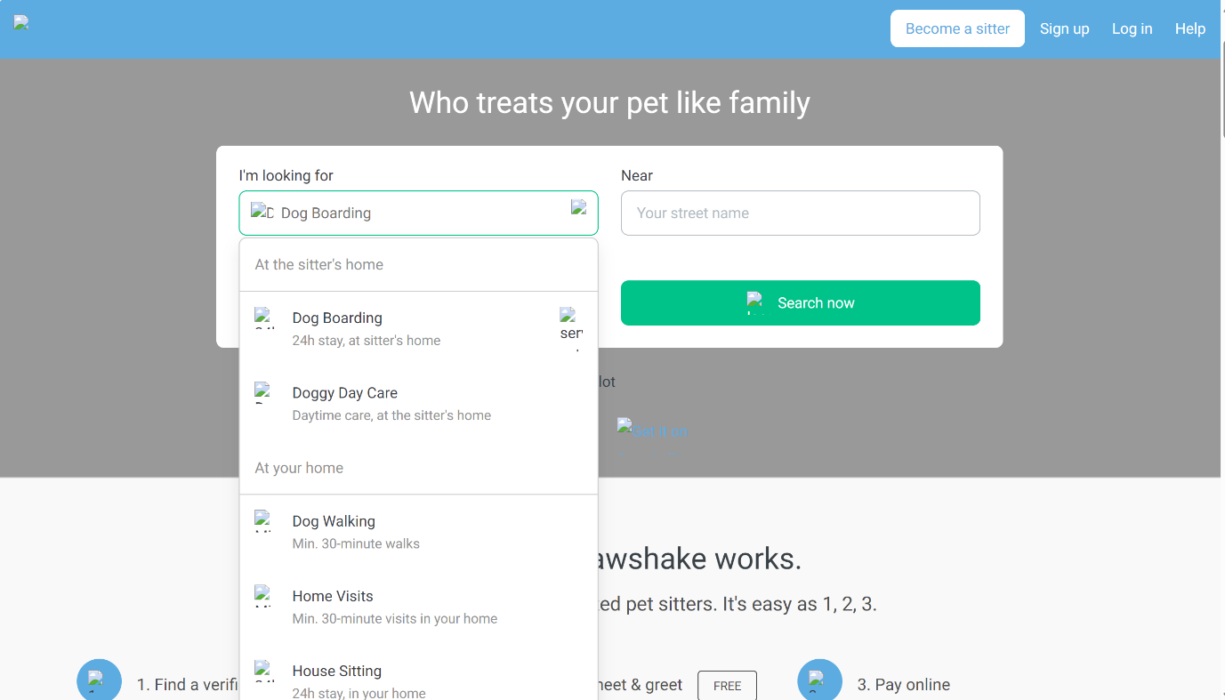

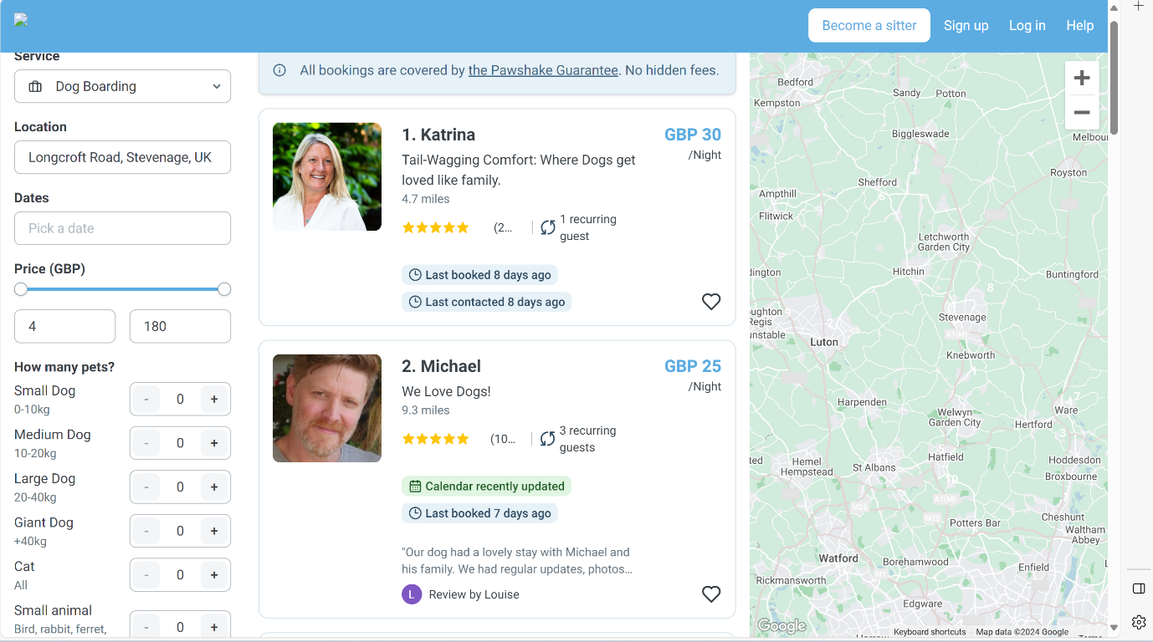

Pawshake.com allows you to input the days that you want to have your pets taken care of. It also allows you to select the type of care that you can’t your pet to have. It also allows you to input your address. All of these feature make it very easy to find a place that is willing to take care of your pets and is located near to where you live.

Another feature that this product has is that it has a pet sitter rating system. This is a very important feature because it allows the user to see if the pet sitter is trustworthy or not. It also has a feature that shows the user how many recurring customers the pet sitters have. This means that if a pet sitter has multiple recurring guests they are good at pet sitting, and take care of the animals.

The website also has a feature that allows the user to select what price range they are looking for. This makes it a lot easier for the user to find a suitable pet sitter.

A problem with this website is that all of the images on the front page failed to load. This could cause the user to lose confidence with the website because if they are failing to load images on their front page there could be other problems with the website, and it suggests that the website is poorly made and other features on the website, such as the rating system, could be faked.

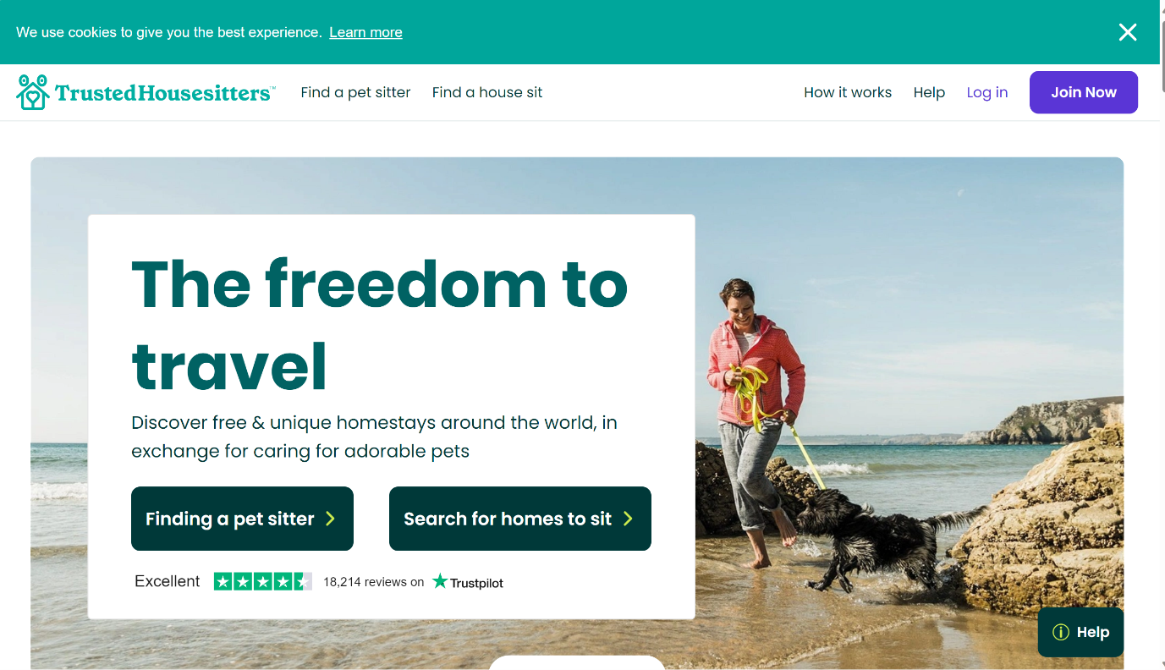Trusted housesitters.com:

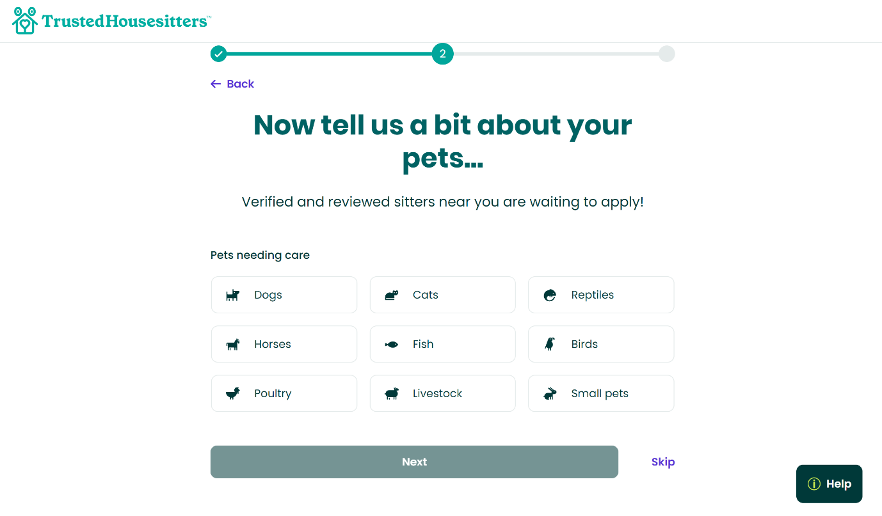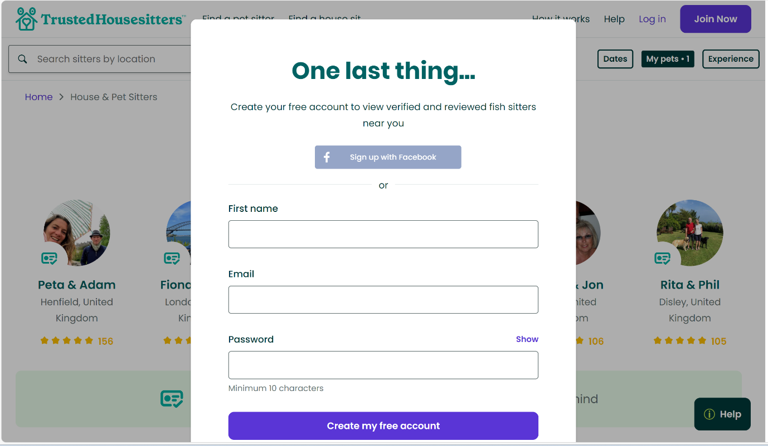

**Features:**

Trusted housesitters.com if a website where you can search for pet or house sitters. This website has a clean and simple GUI. Trusted Housesitters.com allows you to select the animal that you want to get taken care of. This feature is very useful because some pet sitters would be willing to take care of some types of animals like others, for example someone could be willing to take care of a cat, but not a dog. Having the user decide what type of animal that they want to have taken care of before they are shown a list of the pet sitters that are willing to take care of their pet means that they don’t have to go searching through the list of pet sitters looking for someone who is willing to take care of their pet.

To create an account you need to input your first name, your email address and a password. This way of creating an account is easy and fast, and it is secure because for someone to access another person’s account they would have to guess the username and password. Although having the website having the users email address, which would allow pet sitters to contact their client, there is no emergency contacts. Emergency contacts could be very important if there is a problem with the pet sitter or the users pet because it would give the pet sitter a easy and fast way to contact their client, but because only email is listed the only way a pet sitter can communicate with their client is by sending them emails, and it could take a long time for their client to responds because if they are on holiday they might not check their emails.

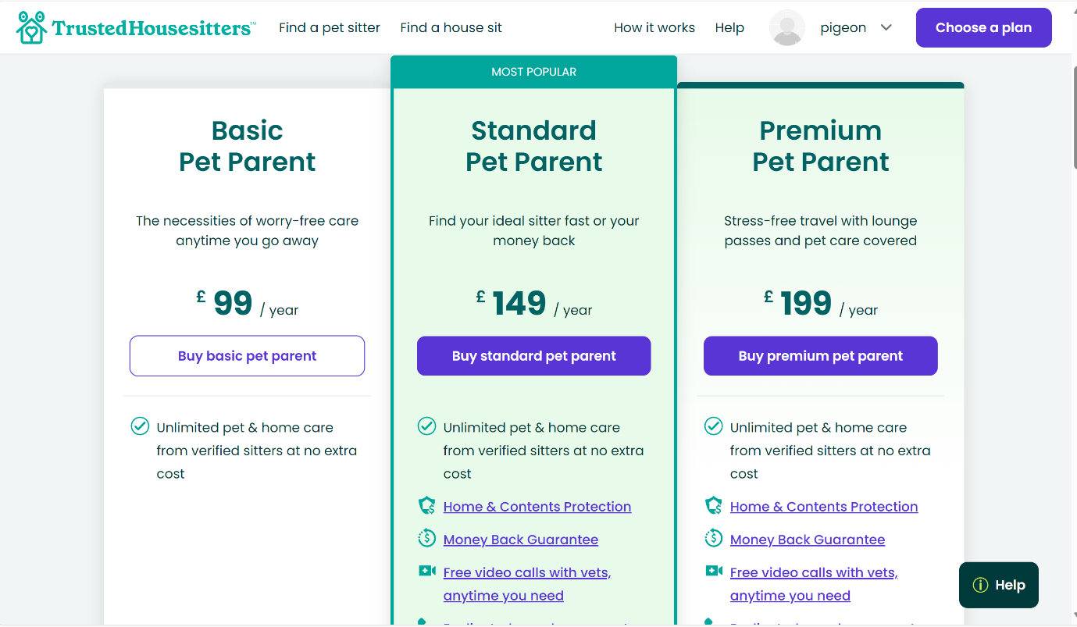

A problem with this website is that it is very expensive. This could be a problem because if you only go on holiday once a year for a couple of days to be able to use trusted house sitters you would have to pay at least £99. This is a problem because most people wouldn’t be willing to pay £99 or over for pet sitters if they don’t go on holiday often.

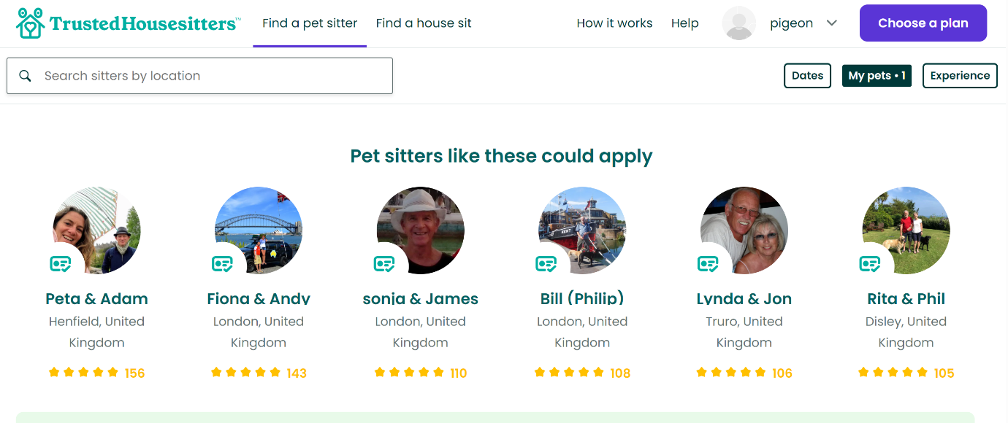

Trusted pet sitters has a rating system for their pet sitters. This is a useful feature because it shows how trustworthy the pet sitters are. I think that this is a very important feature because it will make the user trust the cat sitter more, because if they have a high rating it means that they are very good at petsitting, so the if the user chooses the pet sitter with a high rating they will know that their pets are getting taken care of when they are on holiday.

**Registering as a cat sitter**

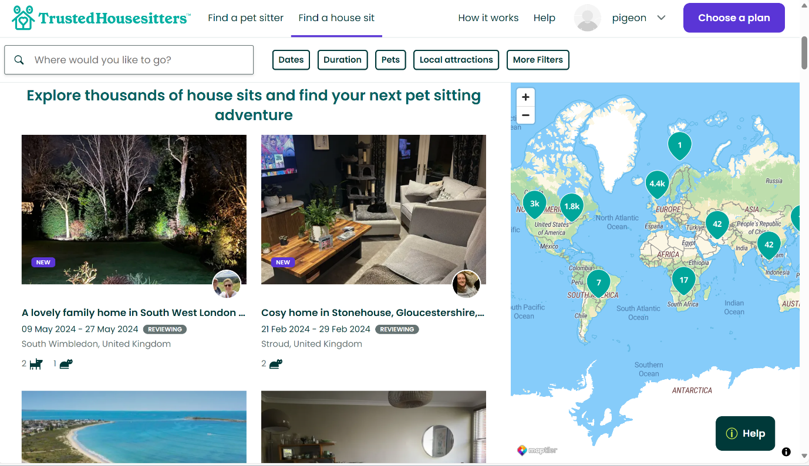

When you are searching for a house to sit it shows you a list of houses that are available to sit. It also shows you if there are pets in the house, and if there are pets in the house it tells you what type of animal they are. There are also photos of the house that the pet sitter can see. All of these features make it a very easy for the pet sitter to decide whether they want to pet sit in the house or not. A problem with the way that TrustedHouseSitters.com filters houses is that it doesn’t ask you where you live, so it could be showing you a house in a different country. This is a problem because the house that you are looking at could be on the other side of the world.

**Summary:**

TrustedHouseSitters.com is a provides a service that allows a pet owner to easily register and find a pet sitter that is willing to take care of their pet, but it is very expensive and it isn’t suitable for people who don’t go on holiday very often.

Trusted HouseSitter.com allows people to register as pet sitters, and find pets that need to be taken care of, but because it can cost up to £199 to register an account as a pet sitter, this high price would dissuade most people from registering as a pet sitter

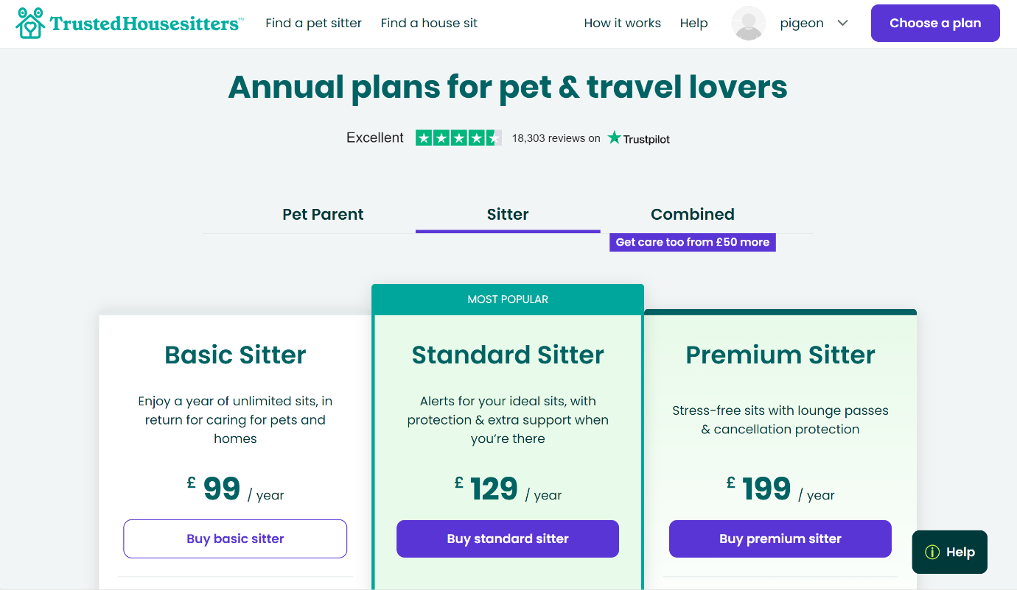

To be able to register on TrustedHouseSitters.com as a pet sitter you have to pay for their yearly subscription fee, which is very expensive. This is a problem because some pet sitters might only pet sit to earn a little bit of money. Having to pay up to £199 to be able to pet sit will make most people not want to use this service.

### HouseSittersUK.com

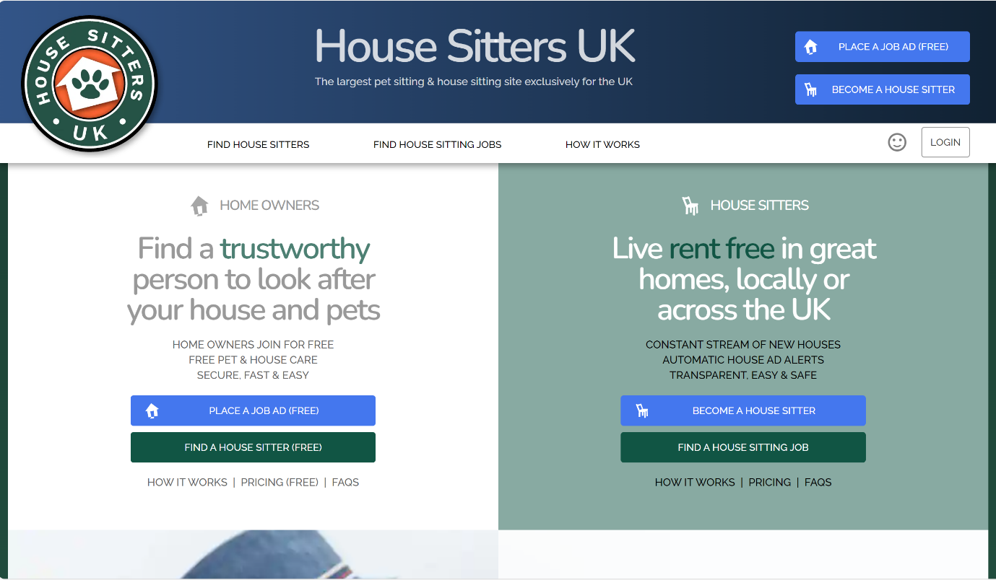

House sitters UK allows a user to register as a user or as a pet/house sitter. The front page of the website is neat and simple, it is very easy for a user to use. This is a very important feature because it makes it easy for the user to register or login.

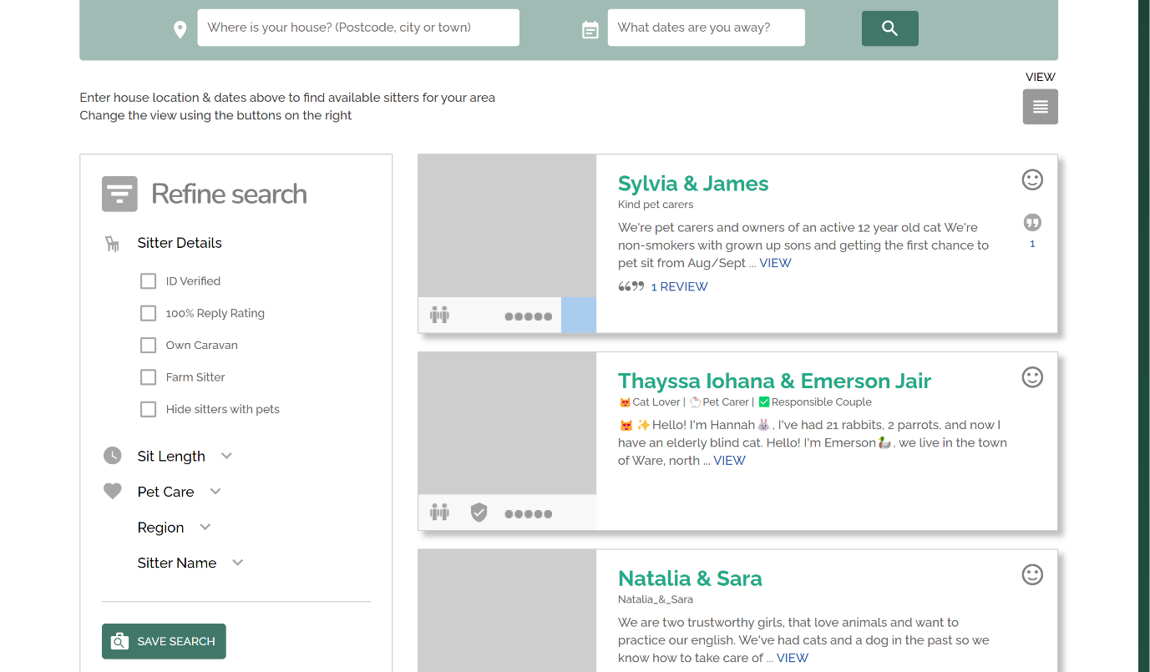

House sitters uk allows the user to input the address, postcode and the days that they will be needing a pet sitter. It also has a sidebar that allows the user to narrow down their search.

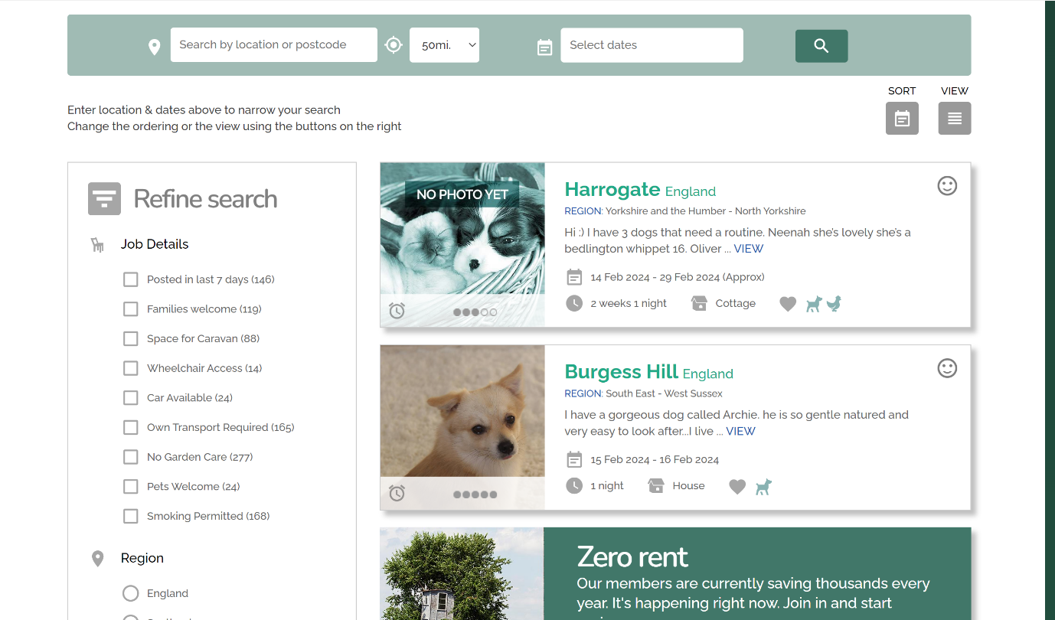

If a pet sitter is looking for a client the website provides a list of potential clients. It also shows what region of the country that they are in, the animals that you will have to take care of, and a rating of the animals behavior. The sidebar also allows you to select options that will narrow down the list of provided clients, so that it is easier to find a good client.

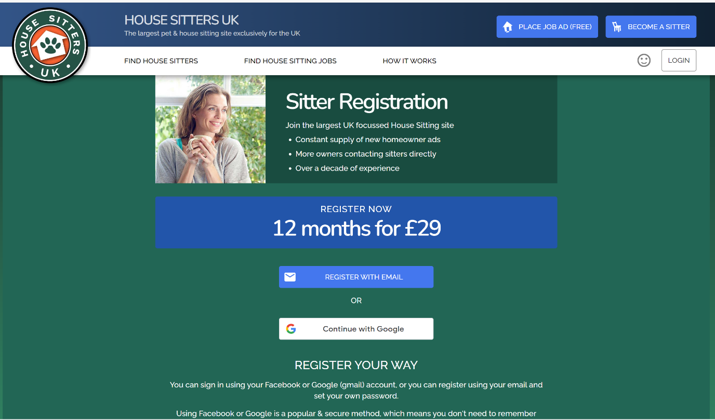

To become a pet sitter you have to pay. Although the amount of money that you have to pay is small the fee could dissuade potential pet sitters from signing up because they might only want to pet sit a couple of times, so it they have to pay a fee they could be losing money instead of gaining it.

### Essential features

The project needs a way to input your address, so that the it is a lot easier to find a cat sitter because they will know that the cat sitter won’t have to travel a long distance to get to their clients house. A cat sitter wouldn’t want to travel a long distance to take care of a cat because if they were using public transport it would be expensive, and if they were using their car the cost of petrol and the wear and tear on their car would be expensive, so this feature would make it a lot easier to find a cat sitter that is willing to come to your house and take care of your cats.

Another feature that this product needs is a way to input the days that you want a cat sitter to come. This is important because there will be days that the cat sitter won’t be able to come and take care of your cats. This feature will make sure it will be very easy to find a cat sitter that is available to take care of your cats on the days that you want them to.

Another feature that this product will need is a method for the user to rate the quality of the cat sitters service. This is important because highly rated cat sitters will give the user assurance that there cats are going to be looked after, and that they can trust the cat sitter.

Another feature that this product needs is that it will need to have database to store user data. This is very important because it will need to hold thigs like user emergency contacts in case something happens when the cat sitter is taking care of the cats. The tables will also store the data that the cat sitters are available to cat sit.

### Limitations

A limitation of this product is that cat sitters and people who want their cats to be taken care of have to live in Hertfordshire. This is because it ensures that the cat sitters will be able to live near the clients that want their cats to be taken care of, so it will be a lot easier to find a suitable cat sitter.

Another limitation of this product is that the only animals that the cat sitters will take care of are cats. This is because it will make finding a cat sitter a lot easier because some people do not like some types of animals.

Another limitation of this product is that if a user live a long distance away from anyone else it won’t be able to make people want to travel that long distance. This could be a problem because the cat sitter having to travel a long distance is that it will use up a lot of petrol, which is expensive, and it will put wear on the car, which would also cost money to repair

Another limitation of this product is that the only type of animal that will be taken care of are cats. This is because some cat sitters wont want to take care of animals like dogs, so having other animals other than cats would make finding a cat sitter more complicated because the user would have to search through the cat sitters and ask if they are willing to take care of their pet.

Another limitation of this product is that it won’t have a direct way for the user to pay the pet sitter. This is because adding a payment mechanism into the website would be too complicated. So instead of the user using the website to pay the pet sitter they would pay the pet sitter on another platform, such as PayPal

### Specification

This product would be on a website because it is easy to access and multiple people would be able to use the service at one time. This would make it a lot easier for users to find pet sitters because they wouldn’t have to stand in line and wait, they could just go onto the website and apply.

This product will also have to have a database that stores user data. This is important because the user will have to login into the website, and the pet sitters would have to login, and the ratings of the pet sitters would have to be stored, otherwise it would be hard to keep track of what the ratings of pet sitters are.

Another thing that this product has to do is present a list of potential pet sitter to the user, so they can choose the one that they want. This is important because users wouldn’t want to leave their pets with a random person, who they didn’t choose.

### Success criteria for the project

To be successful I think that this project has to make it easier for cat owner to find cat sitters. Searching for a cat sitter should be easy and stress free. This project will do this by having a way for cat sitters and cat owners to register onto the website. They will input their details like their address and emergency contact details. This project will do this by being on a website. This product being on a website will make it a lot easier and faster to use because the only thing that the client has to do is look up the URL of the website and go onto it.

This project will also have to have a simple GUI that is easy for the user to navigate. I think that this feature is important because if it had a complicated GUI users could get confused while trying to use it. This would undermine the purpose of this project because the aim of this project is to make it easy for pet owners to hire cat sitters. A simple GUI will be made by not putting too many buttons or search bars for the user to use. This is because the more things that are on the screen at once the more complicated and cluttered it is.

This project will also have to be able to store user login details and emergency contact information. This is important because if there is a problem with the cat’s health or a problem in the clients house. Having emergency contact information available will make it a lot easier for the cat sitter to get into contact with the cat owner.

Another success criteria for this project is that it has to have a neat webpage, that has no problems. This is because a buggy webpage could dissuade users from using the product because they might think that it won’t work.

A way that this project will get measurable success is by asking the user to rate their experience of using the website out of 10. It the rating is above 7 it means that

# Design

## Tables In Database

### Usertable

|  |  |  |  |
| --- | --- | --- | --- |
| Field Name | Data Type | Typical Data | Justification |
| ClientName | VARCHAR(20) | MichaelSmith07 | It is needed, because it allows users to have a unique name on the website |
| First Name | VARCHAR(20) | Michael | It is needed because it is basic data |
| Surname | VARCHAR(20) | Smith | It is needed because it is basic data |
| Email | VARCHAR(20) | Smith.ma@oundleschool.org.uk | It is needed so that the pet sitter can easily get in contact with the user |
| Emergency contact | VARCHAR(20) | 07748923123 | It in required because if something happens while the cat sitter it taking care of the users cat they would need a way to easily contact the user |

### Cat Sitter Table

|  |  |  |  |
| --- | --- | --- | --- |
| Field Name | Data Type | Typical Data | Justification |
| SitterName | VHARCHAR(20) | SmithMichael | It means that all of the cat sitters will have a unique name |
| Fisrtanme | VARCHAR(20) | Michae | It is needed because it is basic data |
| Surname | VARCHAR(20) | Smith | It is needed because it is basic data |
| Email | VARCHAR(20) | Smith.ma@oundleschool.org.uk | It is needed because it allows the client to easily contact the cat sitter |
| Emerganct Contact | VARCHAR(20) | 07923940231 | It is needed because if something happens the client can easily get in contact with the cat sitter |
| Rating | VARCHAR(20) | 4 | It shows to the client that the cat sitter that they hired knows what they are doing, if they have a high rating. This is because the rating would show how good the catsitter is |

### booking

|  |  |  |  |
| --- | --- | --- | --- |
| FeildName | Data Type | Typical Data | justification |
| ClientName | VARCHAR(20) | SmithMichael | It is so that every client would have a unique name. This is so that they don’t get confused |
| SitterName | VARCHAR(20) | MichaelSmith07 | It is so that every pet sitter has a different name, so that they don’t get confused |
| Days | Integer | 5 | It is the number of days that the client is booking the cat sitter for |

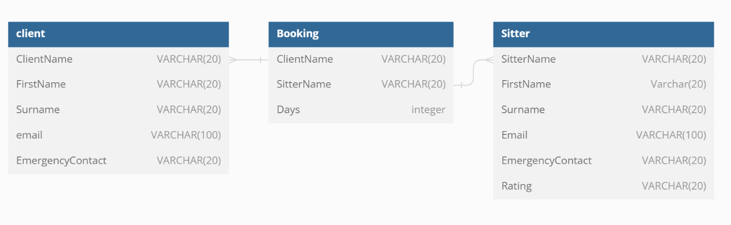

## Webpage design

### Top Down Design

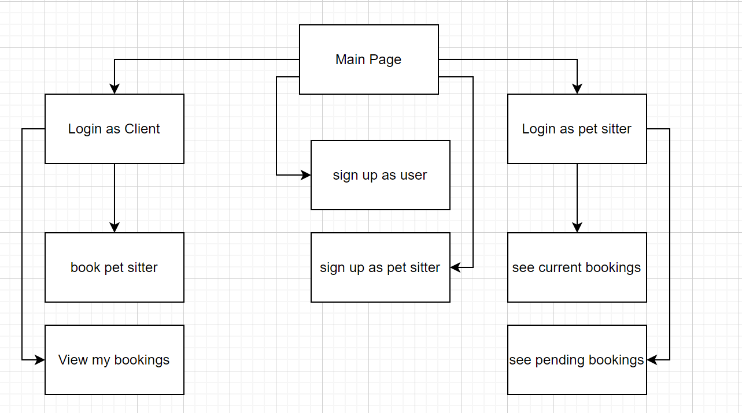

The website will allow users to login, or sign up. If the user is a Client after they login it allows them to book a pet sitter, or see their current bookings. If the Client is booking a pet sitter it will show them a list of possible pet sitter to choose from. If the client goes onto the page that shows them their current bookings it will show them all of their bookings, and it will allow them to cancel the bookings. If the user logs in as a petsitter it will allow them to see their current bookings, and it allows them to cancel their bookings. If they go onto the page called pending bookings it will allow them to to accept or deny bookings

### A screenshot of a website Description automatically generatedFront Page

This page allows the user to either login to their existing account, or to sign up and create a new account. It also has a paragraph about what a cat sitting service is and what it does. I designed this page so that it would be simple, so it would be very easy for the user to navigate. I also want an image slider on the front page because it will show the user what a cat sitter does.

**Usability:**

1. This page allows the user to read about what catsitting is
2. It also shows them pictures of cat sitting
3. It also allows the user to login or sign up to the website

Login Page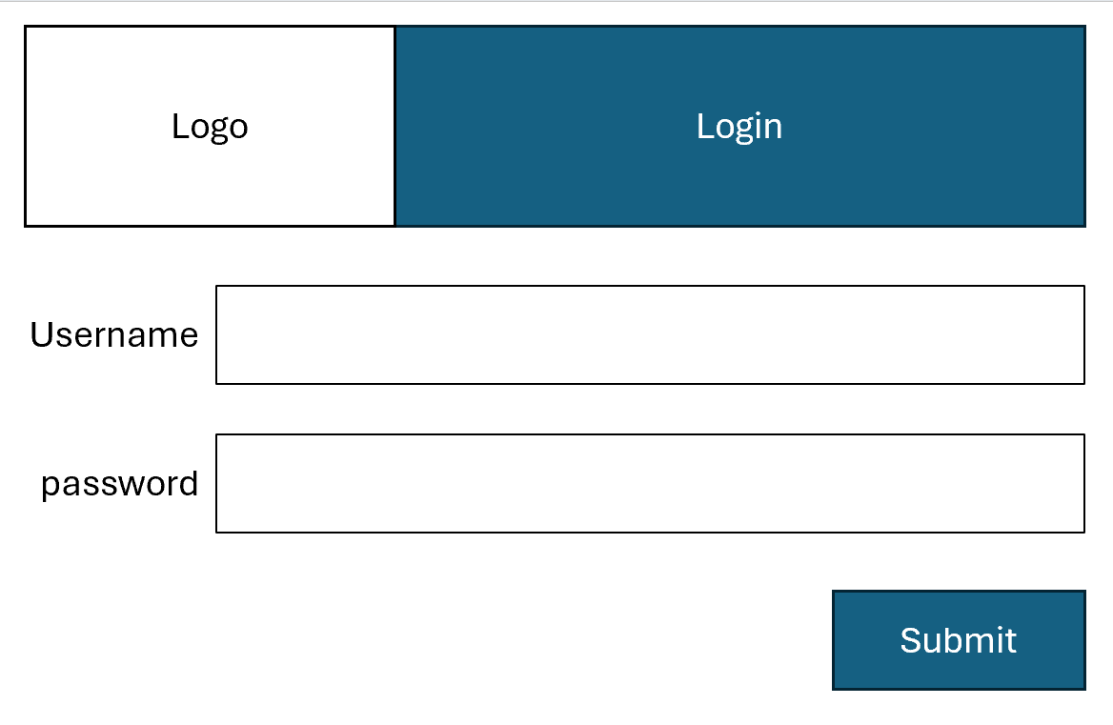

This page allows the user to insert their username and password, and then submit them. If they input the correct username and password it will log them into their account. Users accounts have to be secure because it they weren’t there would be no way of verifying if it was the user who was logging in. The username and password would be stored in a table with the rest of the users credentials.

**Usablility features:**

1. This page allows the user to input their username and password
2. It allows them to submit their username and password so that they can be checked, and if they are correct the user will be signed into their account.

### Sign Up page

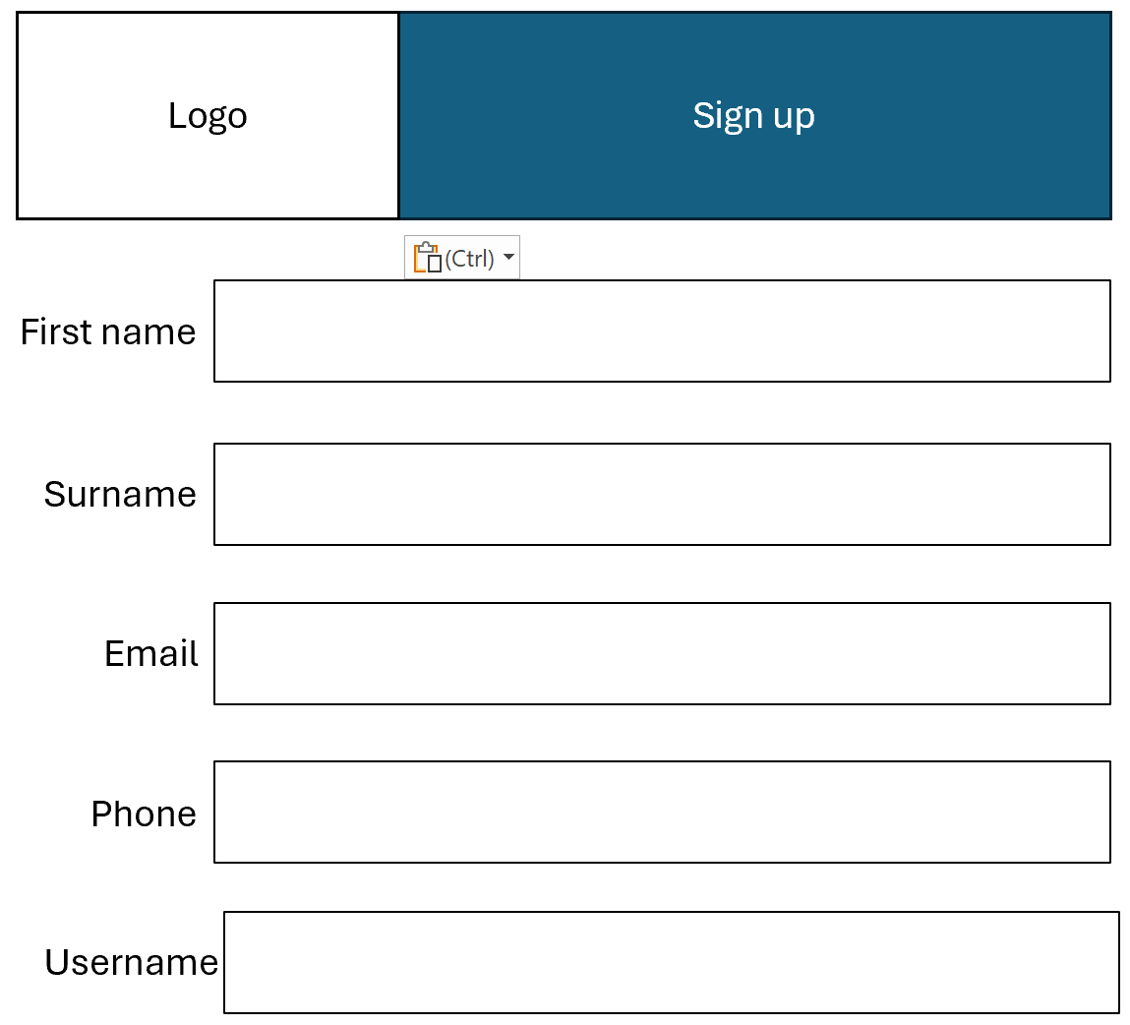This page allows the user to in put their details before they sign up. The user has to input their username because and password because these will make sure that all of the users have different names, so that they won’t get mixed up, and the password makes sure that you can’t login and pretend to be someone else. They need to input their email and phone number. This is because there has to be a record of their contact details, so if something goes wrong while the cat sitter it taking care of their cats they have a way to get their contact details.

**Usability features:**

1. This page allows the user to input their details.
2. It also allows them to submit these details.
3. All details submitted will be stored in a table

### View Bookings

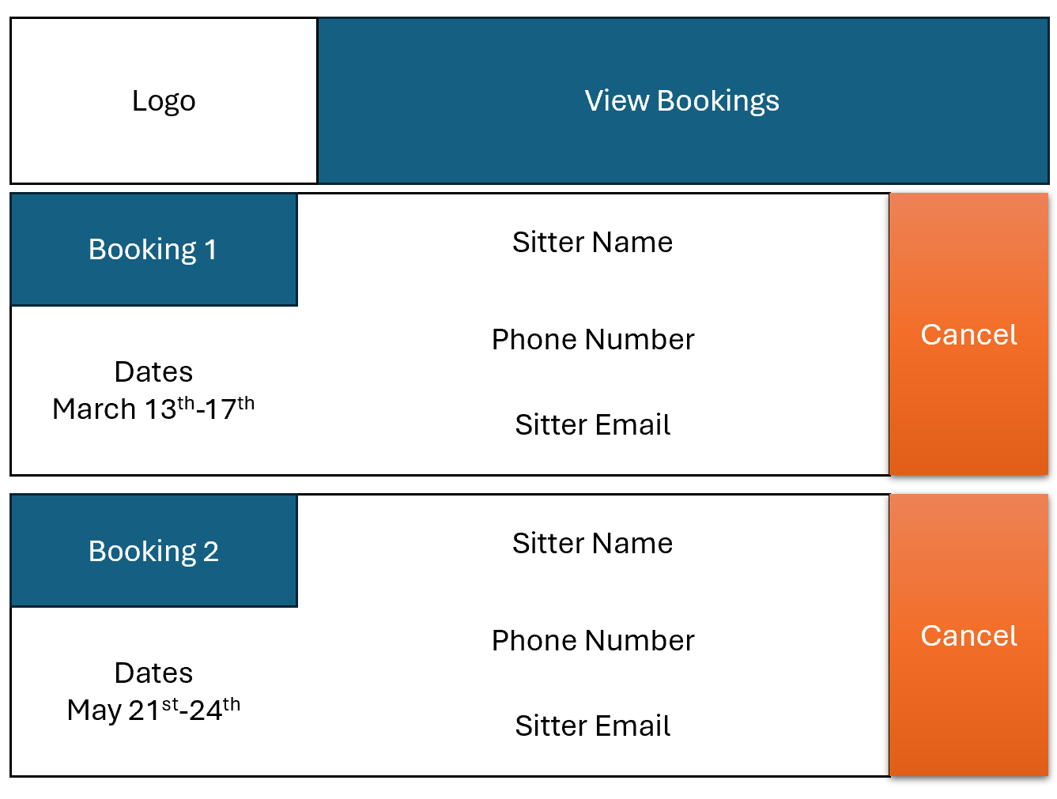

This page allows the user to see all of the bookings that they have made. It also allows the user to cancel their bookings if they don’t need a cat sitter on those days. In the booking it shows the sitters name, their phone number and their email. These details make it easy for the User to contact the Pet sitter if there is a problem.

**Usability features:**

1. This page allows the user to check their current bookings.
2. It also shows the user the details of the cat sitter
3. It shows the user the time and date that they have booked a cat sitter
4. It also allows the user to cancel the bookings

### Create Booking

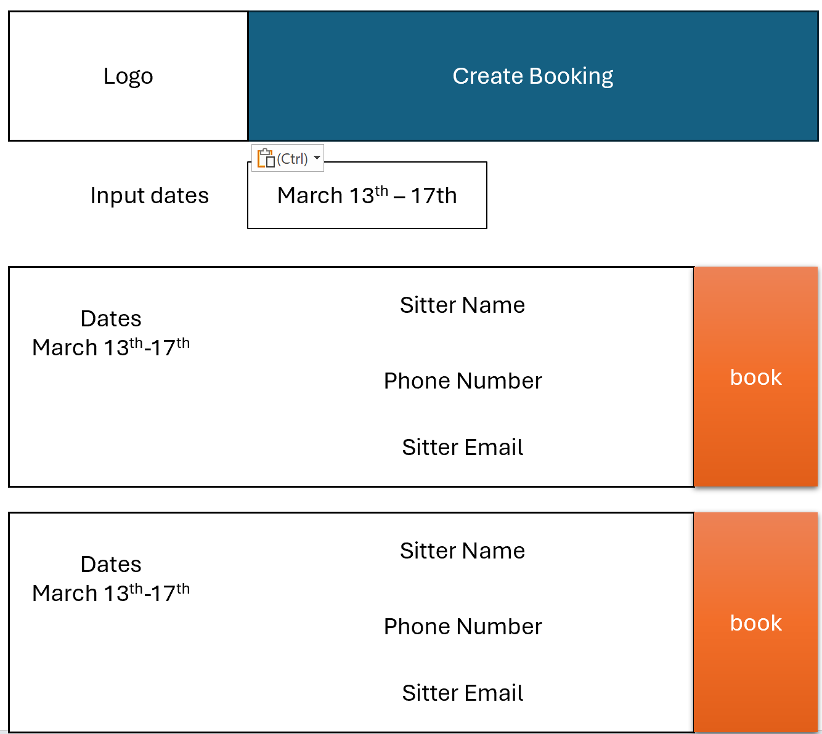

This page allows the user to input the dates that they want a pet sitter on. Then it produces a list of pet sitters that are available at that time. This is so that it is easy for the user to find someone to take care of their cats. This is because all of the cat sitters will be listed in the same place, so the user will know where to look for a cat sitter.

**Usability features:**

1. This table allows the user to input a range of dates.
2. Then it would come up with a list of cat sitters that are available at those dates.
3. It will allow the user to book a certain cat sitter

### Pet sitter View Bookings

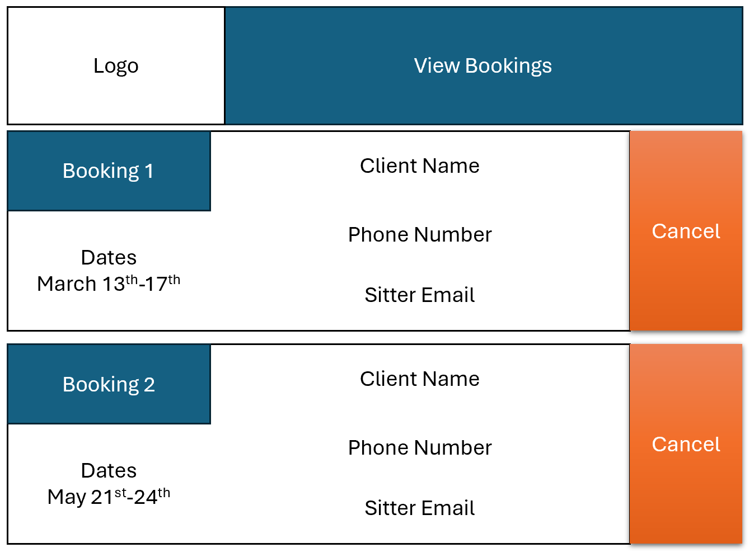

This page shows the cat sitter the times that they are booked to take care of a cat. It shows the clients username, their phone number and email address and the days that they are booked to take care of their cats. There is also a way for cat sitters to cancel their booking if they are unable to take care of the clients cats at the times that they are booked for.

**Userbility features:**

1. This page allows the cat sitter to see their current bookings
2. It also allows them to view the details of their client
3. It allows them to cancel a booking.

# Development

## Main Website

First I set up my website using XAMPP so that I can host the website on my computer. This will make it very easy for me to check whether the website will work with the database properly. It also means that I don’t have to pay to host my website and databases on an online database venor. After my website and databases are complete an end user will test the website.

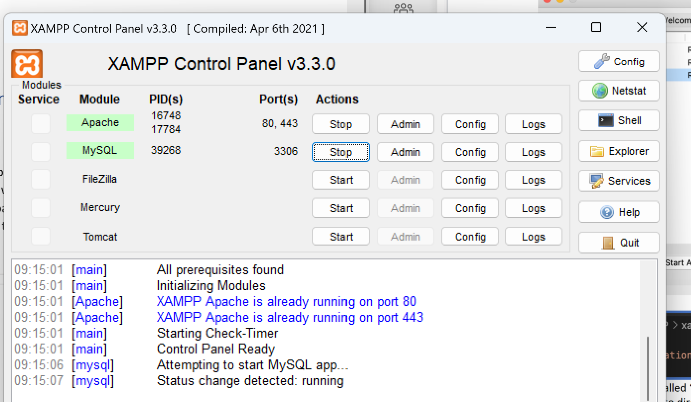

Then I created a folder called computing coursework that I will store all programs in



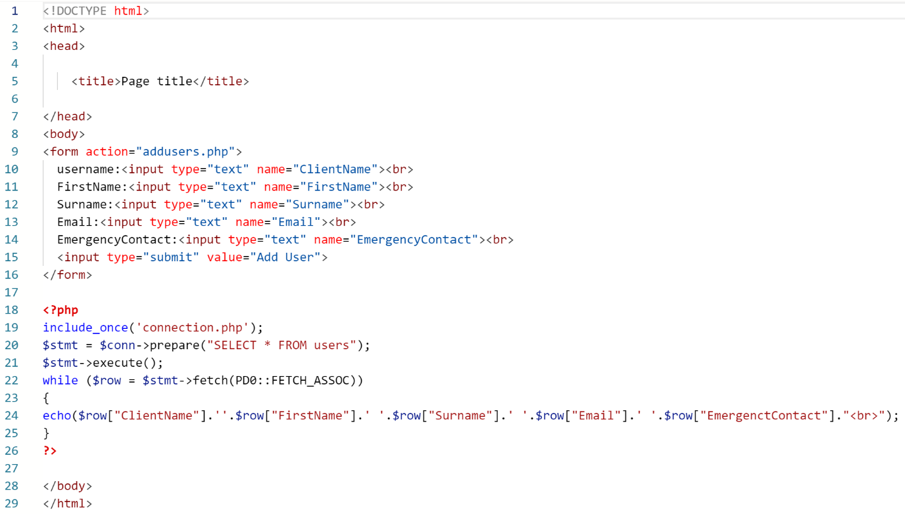

This program puts up input boxes on the webpage. The input boxes allow the users to input their details. In it’s current version it has no CSS stylesheets. In the future I will add a CSS stylesheet so that it looks nicer for the user when they use it.

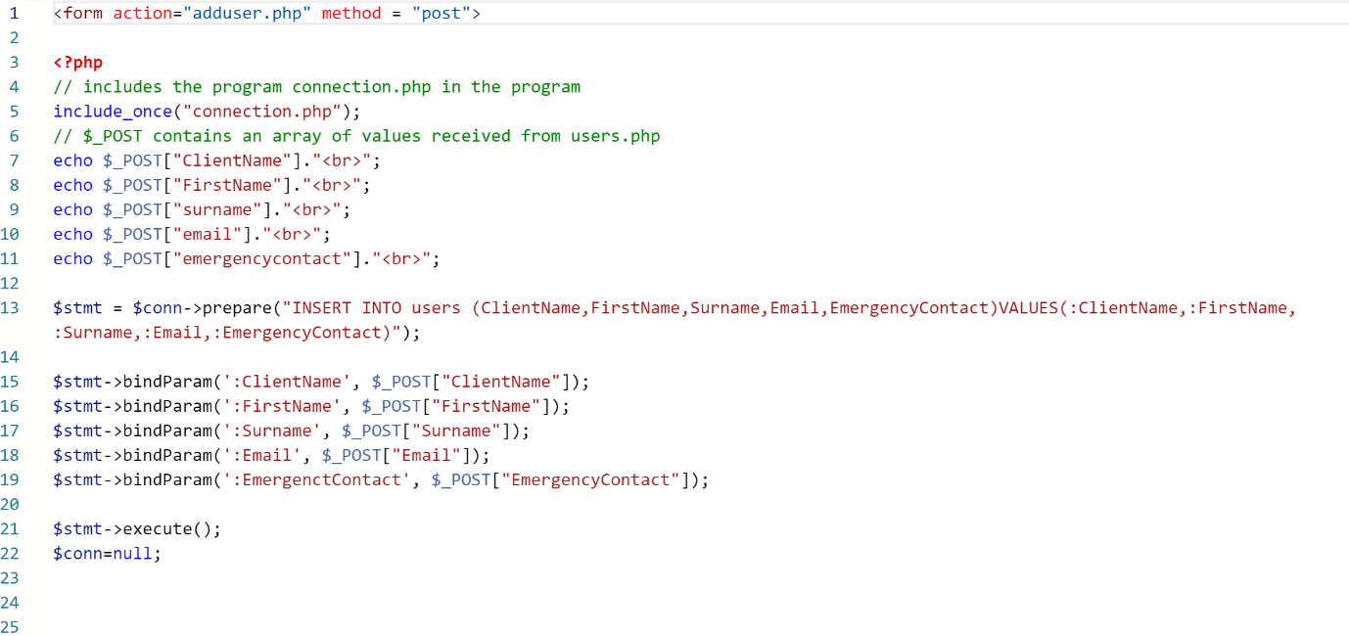

This program takes the values that were insereted into the webpage and adds them into the user table.

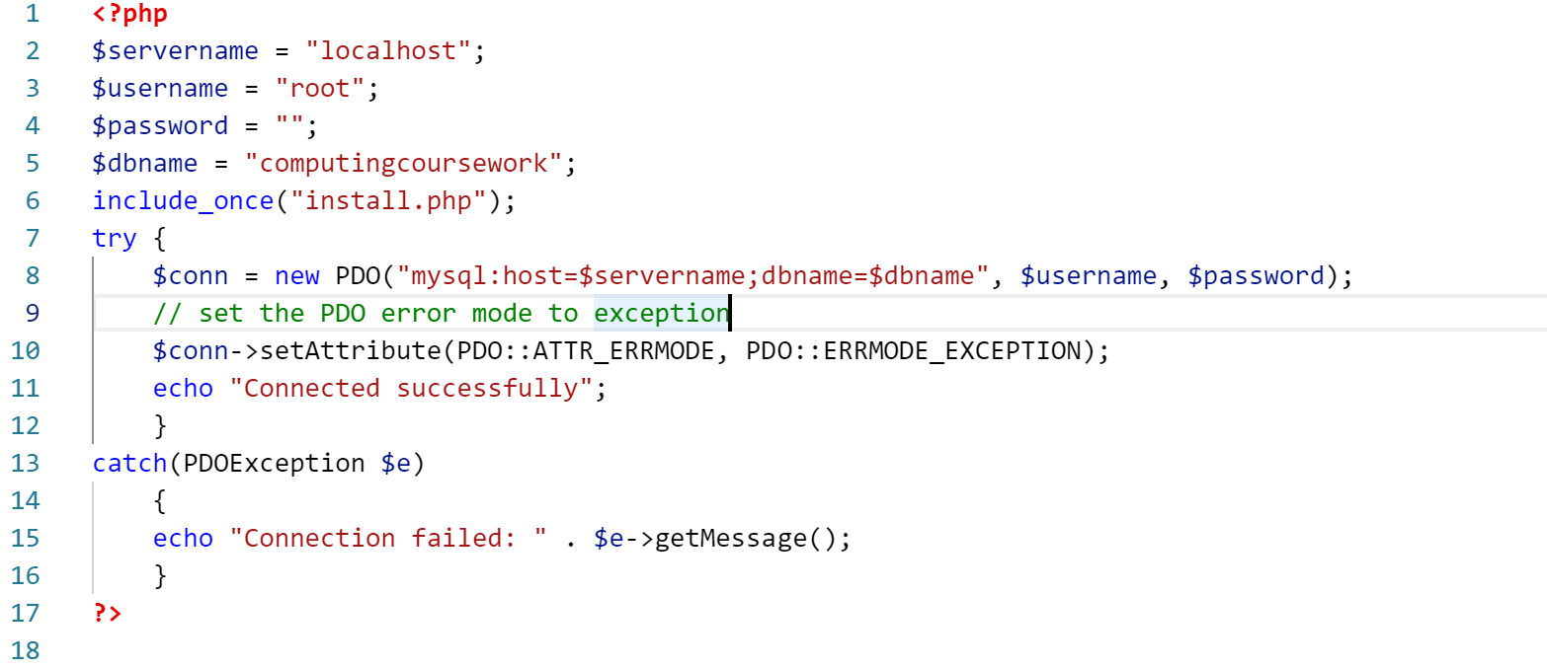

This program connects to the database

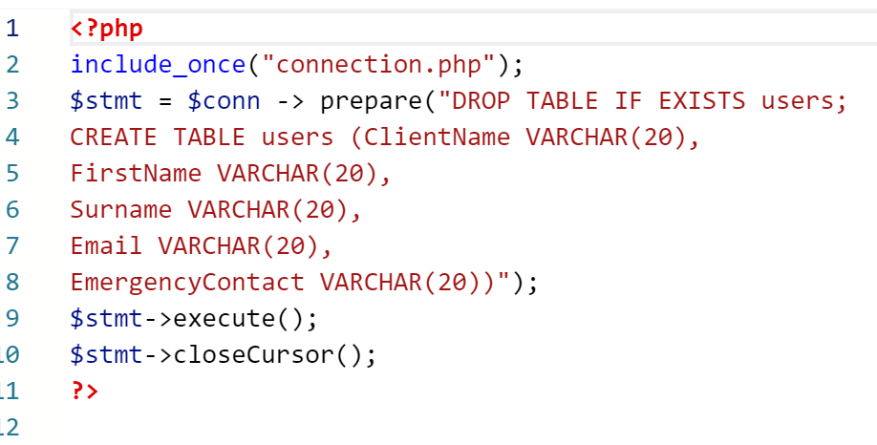

This is the first version of the install program.

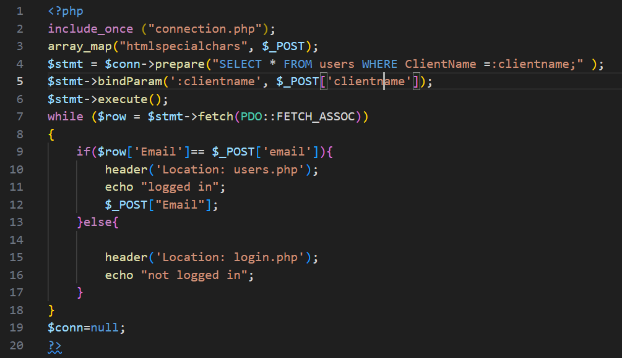

In this program it checks to see if the username and email that are entered matchup with the rows in the database. It does this by getting the table and selecting all of the rows in it, then it goes through all of the rows until it finds a row that has the same username as the username that was entered and it then checks if the email field in that row is the same as the email that is entered. If both of these are true it will allow the user to go through to the home page. A problem with this current code is that it uses email instead of password. This is because there is no password field in the table. I will fix this by adding a password field. Another problem with this program is that there is no way for the website to tell who is logged in to different accounts. This will cause a problem when you are booking pet sitters because the system won’t know who booked a certain cat sitter. I will fix this problem by having a session ID, which will identify the user when they are logged in, so the system will know which user books which cat sitter.

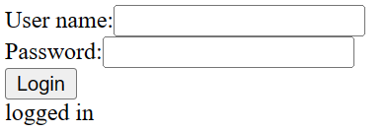

This is the user interface for the login page. I will update the UI to make it more user friendly, currently the user interface is very blocky and uninviting.

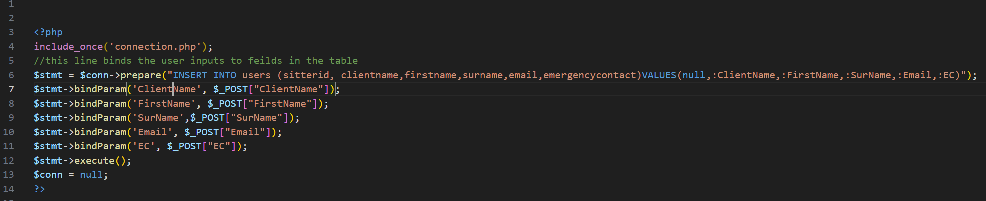This program gets the results of the user input from users.php and it gets all of the fields in the users table. It then inserts the variables from users.php in to the relevant fields in users.php, then the program adds the data in the fields into the relevant tables.

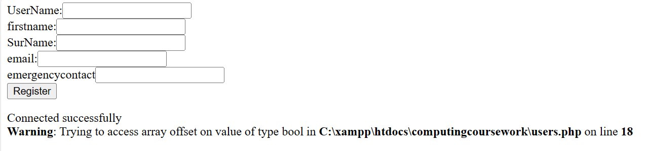

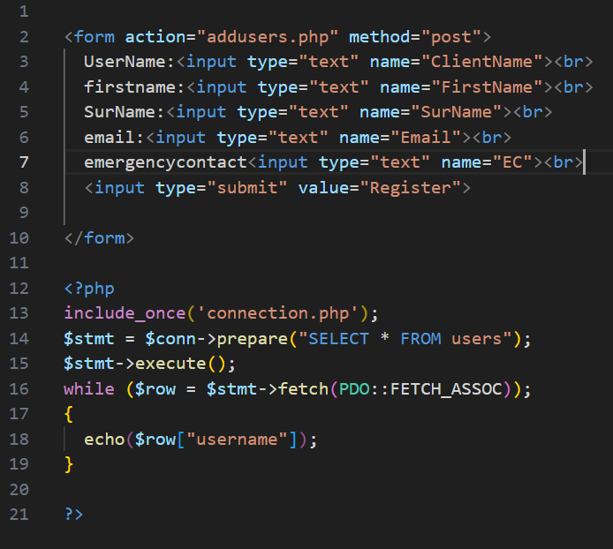

This script get the user to in put all of their details, so that an account can be created for them

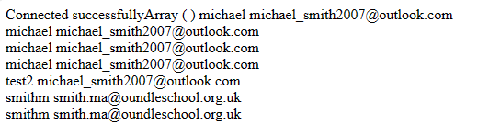

This is the output from the script from addusers.php and it outputs all of the data in the table

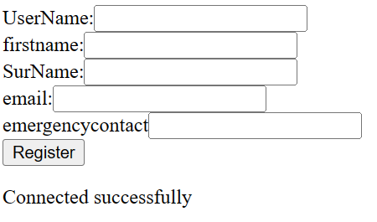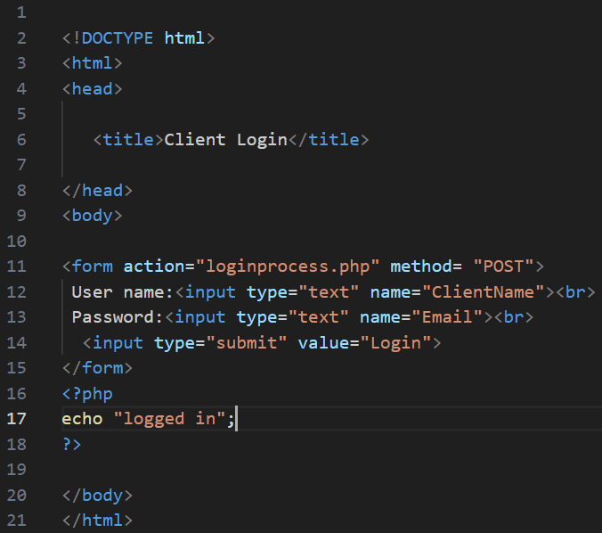

This script gets all of the inputs from the user and sends them to loginprocess.php, where all of the fields ar checked. A problem with this script is that it doesn’t check the data inputted before it is sent off to the database. This could be a problem because someone could in put an offensive term in to the input boxes, or they could input something that could damage the database, like “DROP TABLE Main”. I will fix this problem by writing a JavaScript program that will check the user input boxes.

To book a catsitter the user has to go to the bookings page, where they can select the cat sitter that they want to use and then they can input the start and end date of their booking.

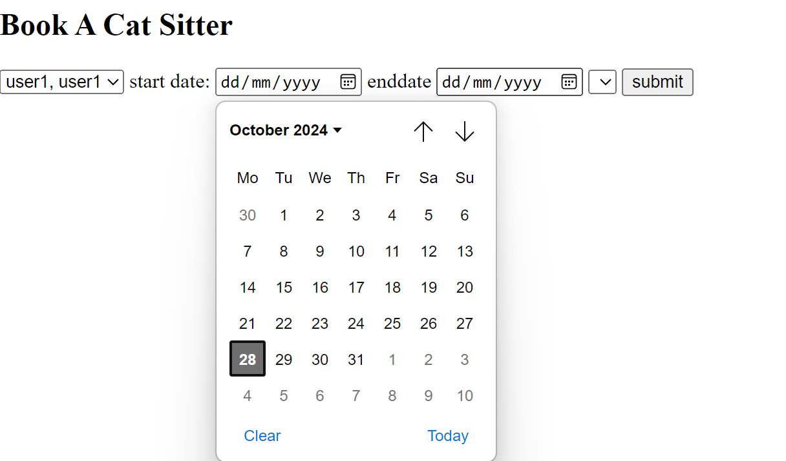

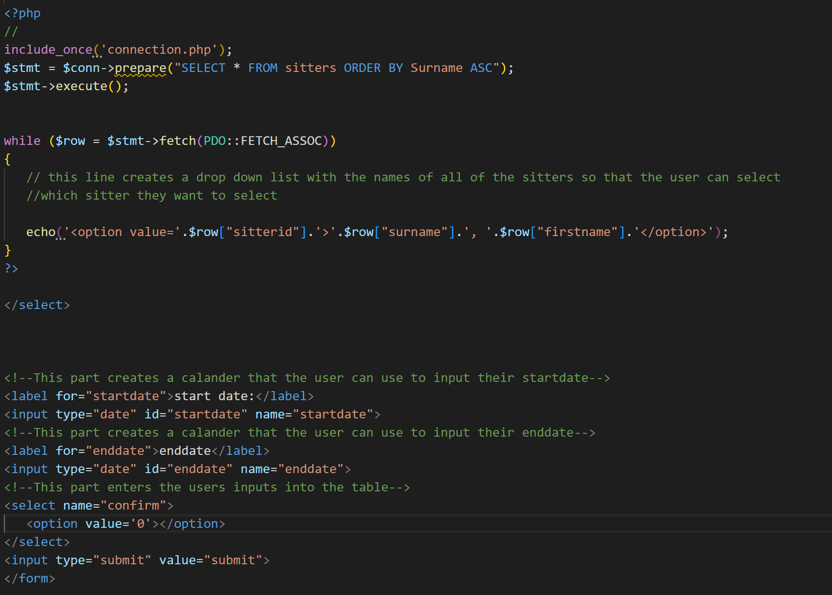

Here is the code for the bookings page. Setting the type of input as a date means that when the user clicks on the start or end date input box a drop down list appears, which makes it easy for the user to input the day that they want to have the catsitter. Once the user has selected the cat sitter and the dates of their booking they will then press the submit button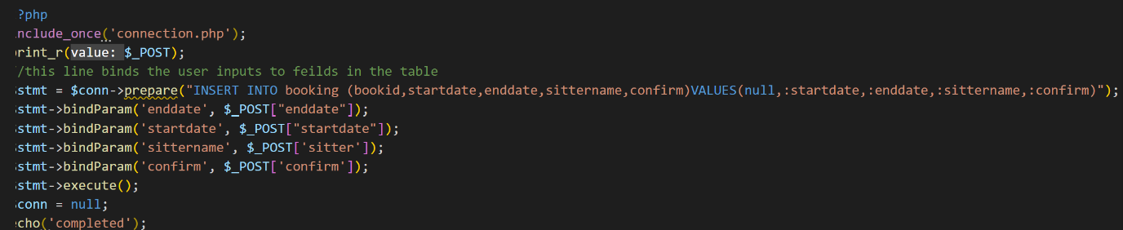

Once the submit button has been pressed all of the inputs from the bookings page are sent to the addbookings page, where they are entered into the unconfirmedbookings table.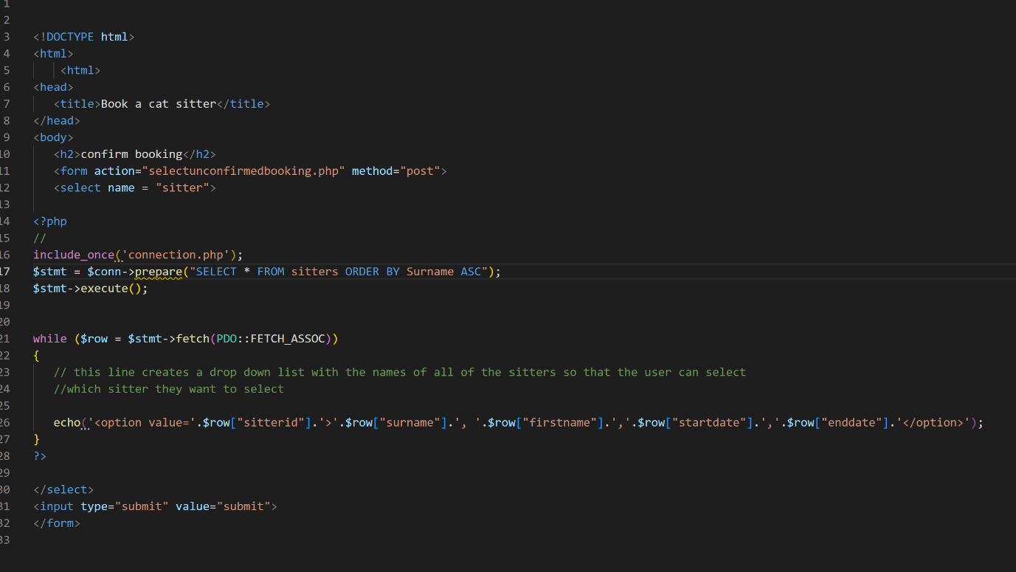

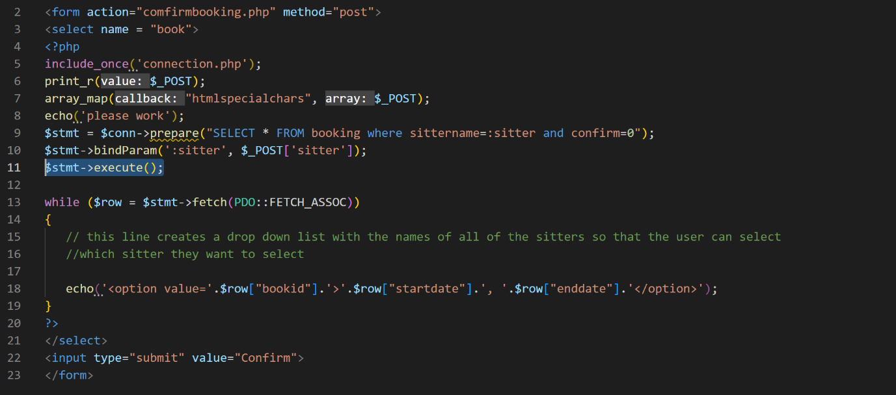

When a user inputs a booking it is an unconfirmed booking and it needs to be confirmed by the sitter that they have selected. This is because the sitter might not be able to cat sit on the days that the user has selected. To do this there is a page that the sitter will see all of the bookings that have been made for them but haven’t been confirmed yet and the y can decide which ones they want to confirm and which ones they don’t want to confirm

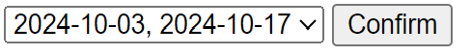

When the sitter clicks the confirm button all of the data in the row in the unconfirmed booking table is copied and inputed into the confirmed booking table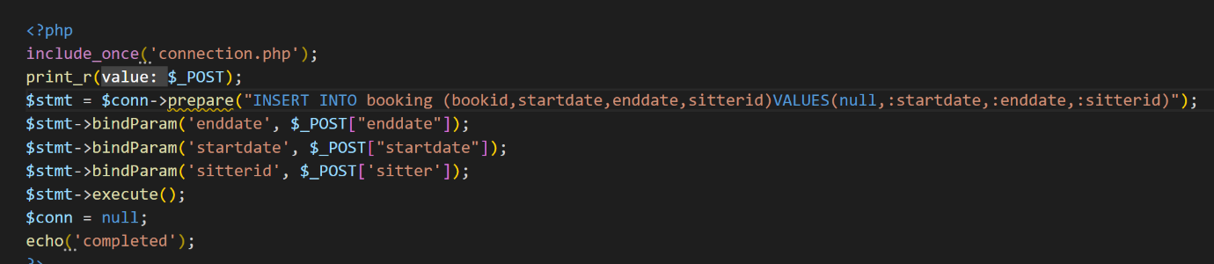

This method of confirming bookings is very inefficient instead of having two tables, one for confirmed bookings and one for unconfirmed bookings I will have one table for both confirmed bookings and unconfirmed bookings, and each of the rows will have a value that will show if it is confirmed or unconfirmed

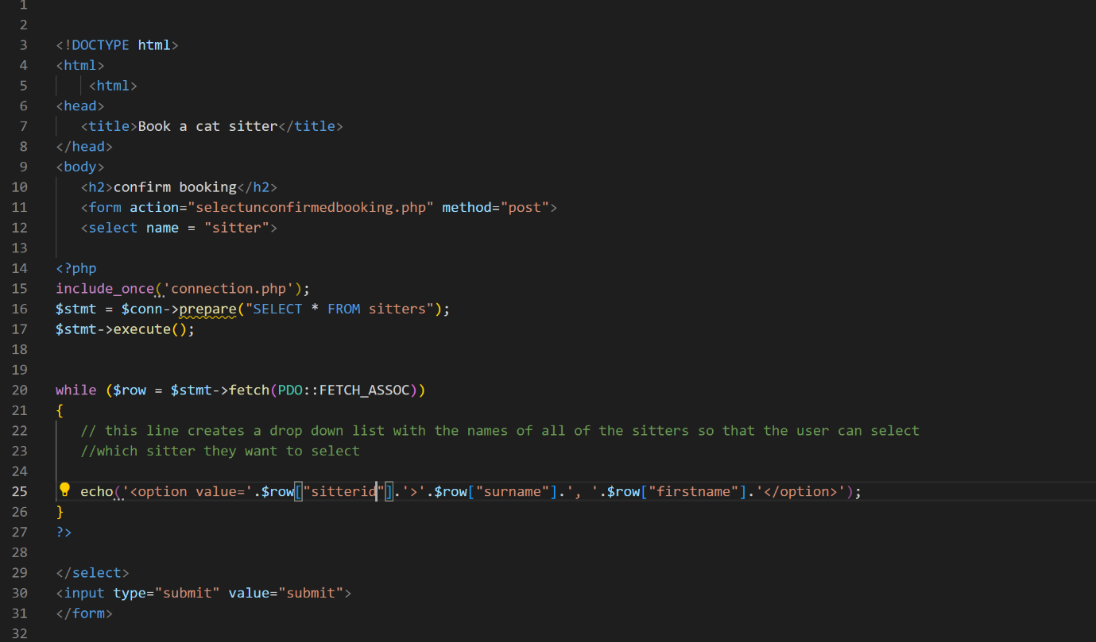

Veiwunconfirmedbookings.php



Selectunconfirmedbookings.php

The line $stmt = $conn->prepare(“select * from booking where sittername=:sitter and confirm=0”); selects all of the sitters unconfirmed bookings because when the confirm value is 0 it means that the booking is unconfirmed. When the user clicks the confirm button it sends their input to the confirm.php page.

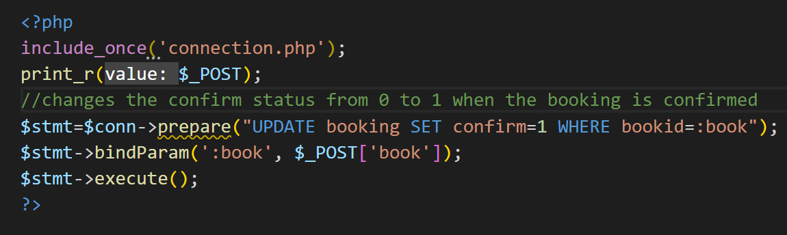

This page gets the bookid that they user inputed in that last page and matches it up to the booking that they want to confirm, then it switches the confirm value to a 1, which means that the booking has been confirmed.

To view unconfirmed bookings the client and the cat siter would go to the veiwbookings page

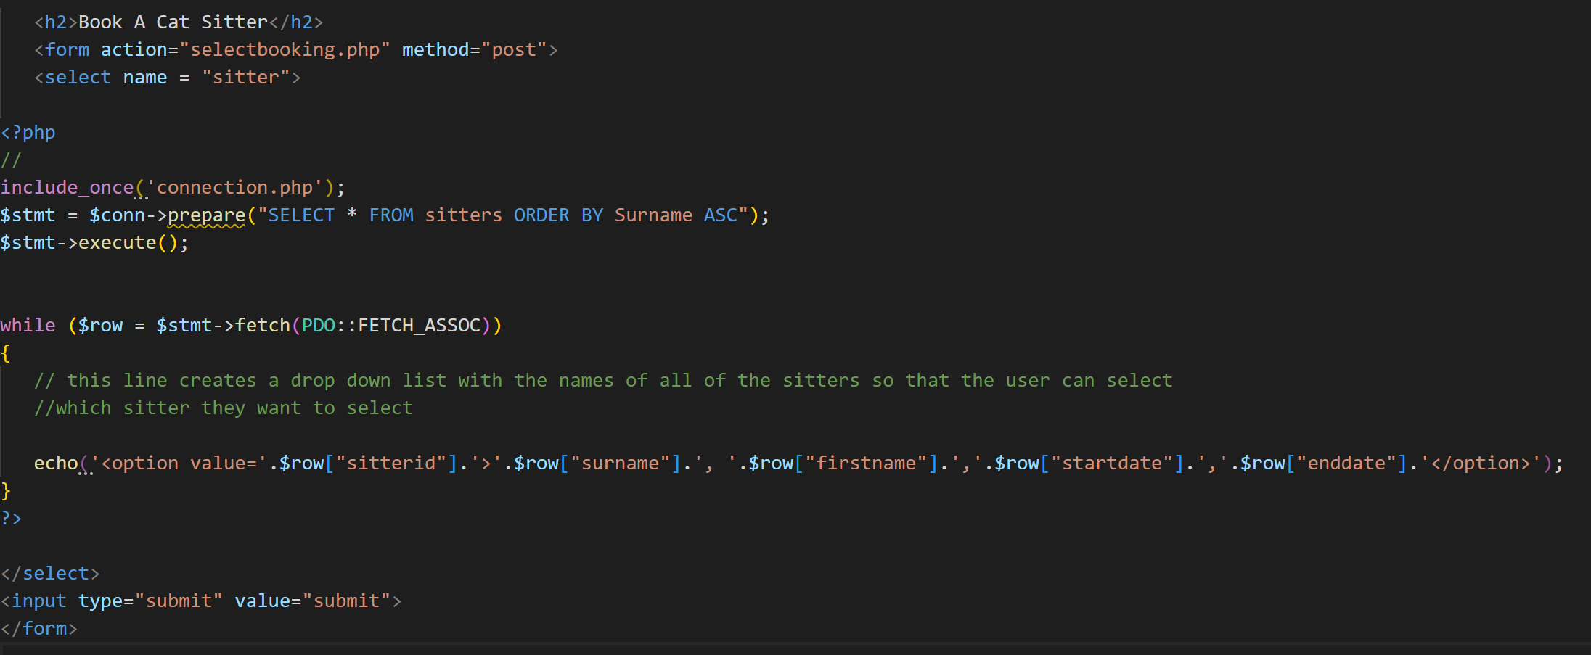

Veiwbooking.php

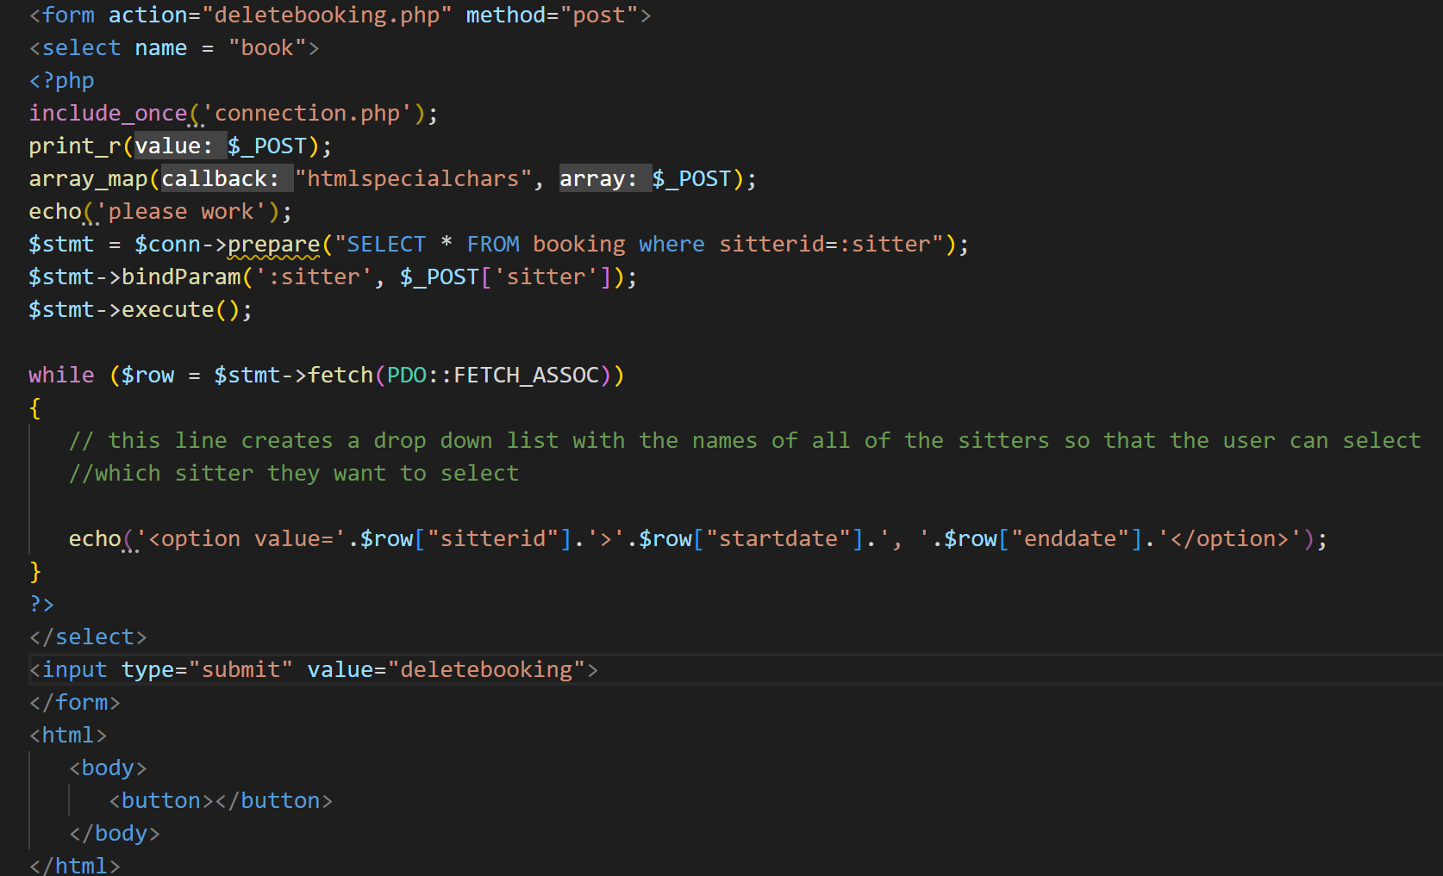

Selectbooking

The select booking page allows the user to veiw the dates of the bookings that they have. A problem with the current version of this page is that it doesn’t tell the user which client the booking is for or where they have to go for the booking. If the sitter wants to get rid of the booking they would click the delete booking button.

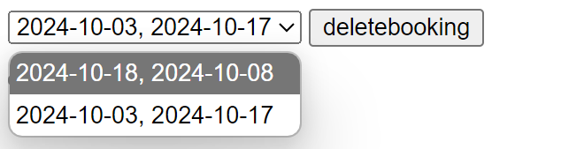

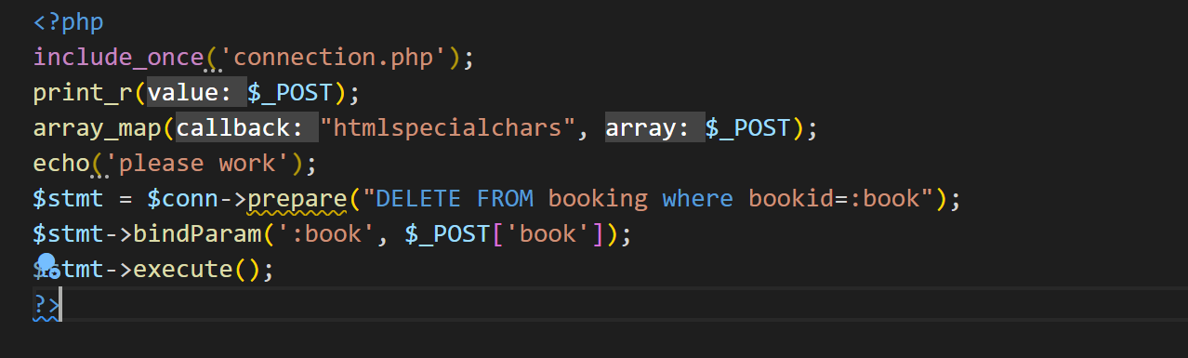when the user clicks the delete booking button the deletebooking.php page will get the user input from the selectbookings.php page and match it up to the bokid of the booking that they want to delete, then it deletes the booking

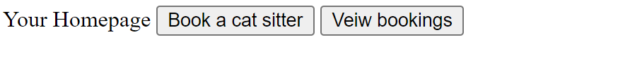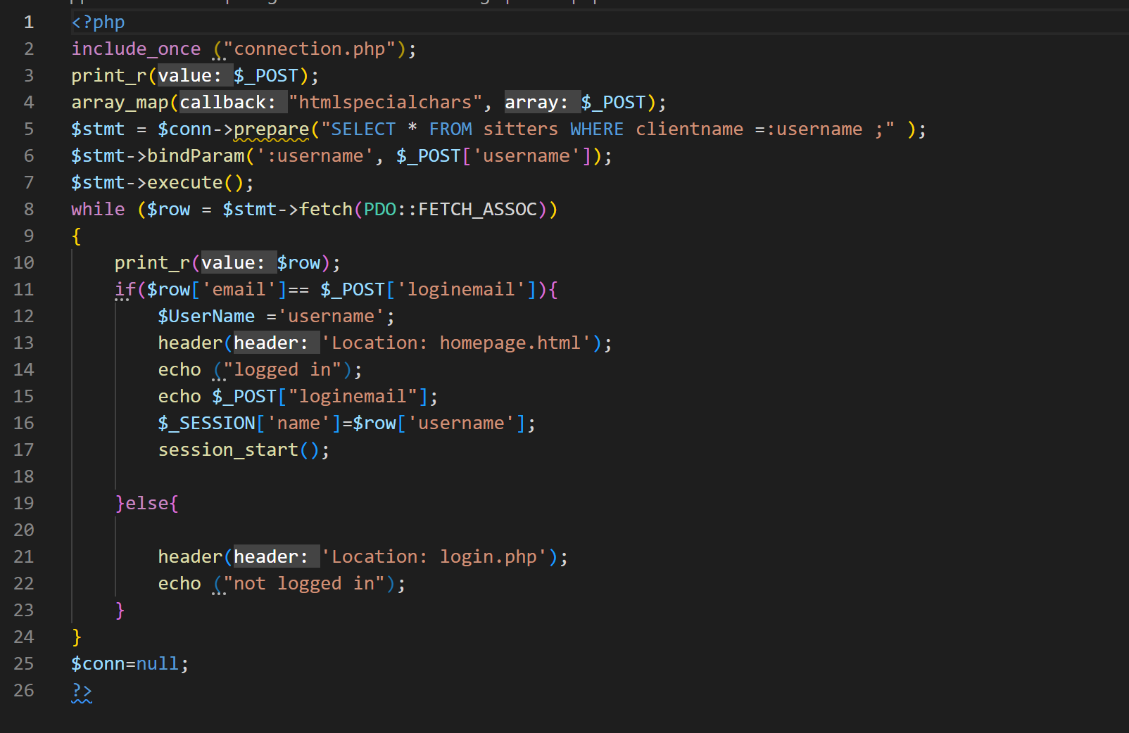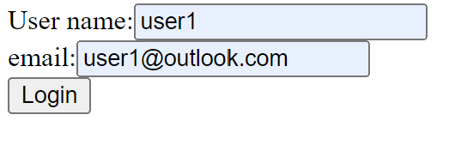

A problem with the current booking system is that no data from the user is stored in the table. This means that there is no way for the cat sitter to see which user has booked their services and it also means that there is no way for the user to cancel their booking.

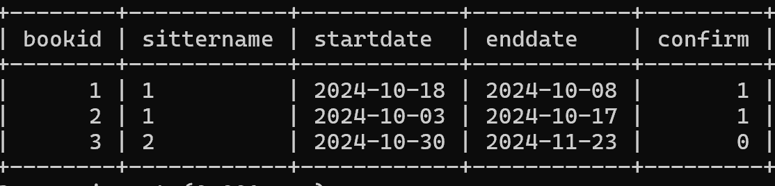

In this table there is no data identifying the user that booked the booking.

A way to fix this problem is to add column to the table that records the users id.

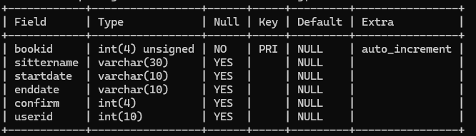

The new bookings table has the same columns as the old booking table but it has an extra column tto hold the userid, which allows the user that made the booking to be identified.

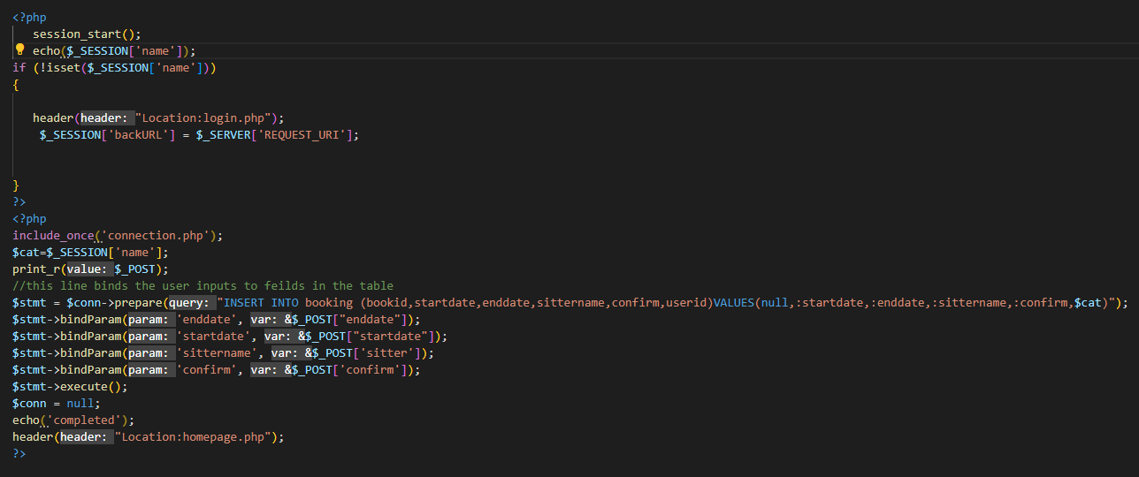

Because of the new column in the table the code that creates the booking had to be changed slightly. Firstly I had to put the code that gets the session variable at the top of the page and in the line of code that inserts data into the table I had to add a bit that gets the user id from the session variable and binds it to the userid column of the table. This change means that now there is record of which user has booked a sitter.

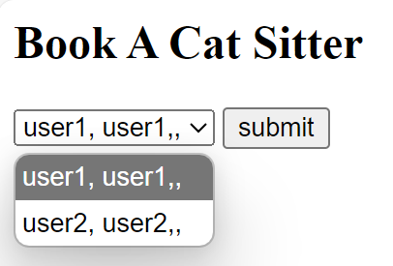

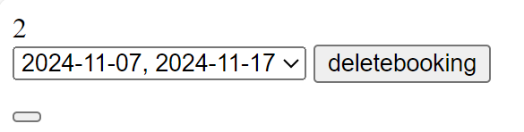

The a user is to access a sitters view booking page . This is a problem because it means